Sustaining Gains

Continuous distribution strategy for LLIN through communities in Nasarawa State

Design document for state-wide implementation

Draft 17.04.2012

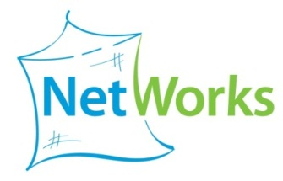
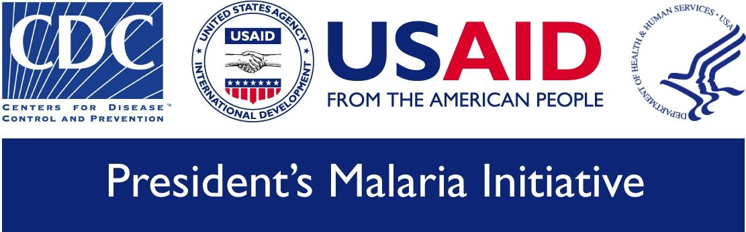
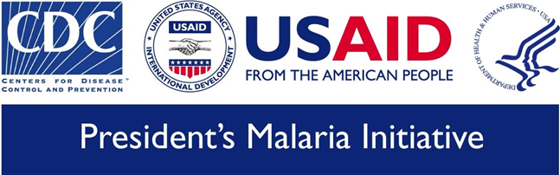
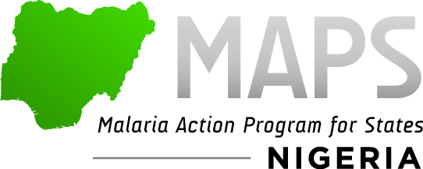

Table of Contents
Introduction 3
Situation Analysis 3
Recent LLIN distributions in Nasarawa 3
Existing community–based health interventions 4
Observations on the current CDD system 4
The general concept of continuous distribution 5
Projection of LLIN needs and options for distribution channels 6
LLIN needed to sustain target coverage 6
Potential output of various channels 6
Proposed community-based distribution system 7
General principles 7
Detailed description of distribution 7
Implementation 9
Quantification and allocation of nets 9
Mobilization and BCC 10
Distribution 10
Roles and responsibilities 11
Monitoring and Evaluation 11
Routine data and their flow 11
Population based surveys for evaluation 12
Next steps 12
Annex 13

Introduction

MAPS (Malaria Action Program for States) and NetWorks are two USAID funded projects which support malaria control in Nigeria. While MAPS is country specific supporting all aspects of program implementation, NetWorks is global and focuses on all aspects relating to malaria prevention using Long-Lasting Insecticidal Nets (LLIN). In the Nigerian context NetWorks has been tasked to support MAPS in designing innovative distribution systems for LLIN in order to sustain the gains from recent campaigns, evaluate the successes and carry out operational studies that can contribute to a better understanding of crucial issues and improve implementation strategies.

One of the states supported by MAPS is Nasarawa where the LLIN distribution campaign took place in December 2010. This state has a long established community-based system for mass drug administration for Onchocerciasis, Lymphatic Filariasis, Trachoma and Schistosomiasis which uses Community Drug Distributors (CDD). Such a system has potential to also serve as a channel for LLIN distributions and in order to explore this option a joint mission was carried out in November 2011 jointly by the State Malaria Program, MAPS and NetWorks. Following meetings with the State authorities for Health discussions were held with key partners and stakeholders (UNICEF, WHO) and departments of the State Ministry of Health (Onchocerciasis Control and HMIS). This was followed by field visits to two LGA (Kukona and Akwang) including discussions with the LGA health teams, visit of a health facility and discussions with a number of CDD. A one-day work-shop then presented the options the team had developed to the stakeholders and preferences and challenges were discussed. Results from the exploration mission were presented to USAID and also discussed at a meeting with representatives of communities and the CDD.

Building on the consensus reached thus far this document presents a proposal for micro-planning and implementation.

Situation Analysis

Recent LLIN distributions in Nasarawa
Distributions of LLIN started in Nasarawa in 2005 but were limited to nine out of the 13 LGA and targeted to children under five and pregnant women. They were supported by the Carter Centre which used the CDD system for distribution and by UNICEF and totaled about 120,000 (compared to a population of 1.8 million in 2006). The Demographic and Health Survey (DHS) from 2008 net ownership for 25% of households and 14% owned at least one ITN. Small numbers continued to be distributed in 2009 and 2010 (around 40,000) and in December 2010 842,324 LLIN were distributed targeting the general population with 2 LLIN for every household. Based on the post-campaign survey from November 2011 72% of households were registered for the campaign and 61% received at least one LLIN. While none of the sampled communities were missed entirely, in 7% less than half of households were registered and in 62% of communities between 50% and 80%. This would suggest that in total up to 165,000 households were missed by the campaign.

Existing community–based health interventions
The system of Community Drug Distributers (CDD) was first established for the African Program for Onchocerciasis (APOC) for the Community Directed Treatment with Ivermectin (CDTI) which was supported by the Carter Centre and expanded to include Albendazol treatment for Lymphatic Filariasis (LF) as well as Praziquantel for Schistosomiasis and was renamed Community Directed Interventions (CDI). Based on APOC guidelines CDD are selected by the communities and trained and supervised by the health staff from facilities and LGAs. Every year they register the population in the village (targeted ratio of 1 CDD per 250 persons) and based on these registers medicine allocations are made. Supplies are provided as donations through the Carter Centre and delivered to the LGAs. Facilities are then informed of the arrival and asked to pick up their assignments and the facilities in turn inform the CDD who then collect the medicines from the facility (no transport provided). CDDs then treat the target population and submit the reports to the supervisors. Communities are encouraged to provide support to the CDD in kind or payments but no incentives are given by the program. While onchocerciasis control is more focal and therefore does not cover the entire State, the LF program is state-wide and includes the urban areas.

Observations on the current CDD system
Some high-lights from the field assessment undertaken in November 2011 can be summarized as follows:
At State level
- CDD program seems well established and respected by key partners
- However, coordination of community activities may need better coordination as there appears to be some duplication e.g. of community registrations
At LGA level
- Heath teams struggle at times with the logistics support, i.e. to find means of transport for drugs and supplies unless commodities are directly delivered by the donor (e.g. vaccines from UNICEF)
- Generally staff was very open to the idea of a continuous distribution system for LLIN as the campaign activities were perceived as very intense and stressful
- A majority of staff also felt that a system where households have to take a more active role in order to receive nets was feasible and could be advantageous
- Attrition rates among CDD seem to be high in some places (up to 50%) and not all communities get covered for mass treatment at times
At facility level
- Distributions through ANC have happened before and are welcomed
- Storage capacity in the visited facility was sufficient at least for the demand for ANC distributions (70-80 per month)
- There was some reservation regarding the possible distribution of community nets through the facility and it was suggested that this be done through other mechanisms
At CDD level
- CDD reported that some of them cover up to 7 villages and 2,000 to even 8,000 people while other only had 200 or even less
- All felt disappointed at times by not being sufficiently recognized by the communities
- They generally welcomed the idea of engaging in LLIN distributions (Akwanga had been part of the previous CDD LLIN distribution in 2004) and expect to then be valued more by their communities

The general concept of continuous distribution

Following the dramatic scale up of LLIN distributions throughout Sub-Sahara Africa through mass distribution campaigns in the past 5-6 years it is increasingly realized by the Roll Back Malaria Partnership that repeated campaigns are not the best solution to sustain the achieved gains and that a comprehensive distribution strategy which includes continuous distribution mechanisms are needed. The purpose of such continuous LLIN distribution is to
- Avoid decline of population coverage (and hence protection) to levels below the threshold of the mass effect between repeated campaigns caused by the loss of nets through wear and tear
- To provide replacement nets as well supply new families when and where this is needed and to do this in an equitable and sustainable manner

Two principle approaches are possible which are shown in Figure 1. The most common way is to use routine services in health to give LLIN to persons at particular risk such as pregnant women through ANC or children when they come for immunization. The eligibility to receive an LLIN is defined exclusively by the attendance at the specific services and therefore these distributions are called routine distributions in the strict sense. They can also been described as a push system.

The second approach consists of distribution mechanisms which are initiated by those who have a perceived demand for nets and then gain access to a full-price or subsidized system. This can also be described as a pull or demand-driven system and includes among others the classical social marketing.

A combination of the two would be a push-pull system where a certain amount of nets is pushed to a certain point in the supply chain (hub) from where the net users can pull down nets according to their demand and based on defined eligibility criteria.

Figure 1: Continuous distributions through routine services (push) or community/demand driven (pull)
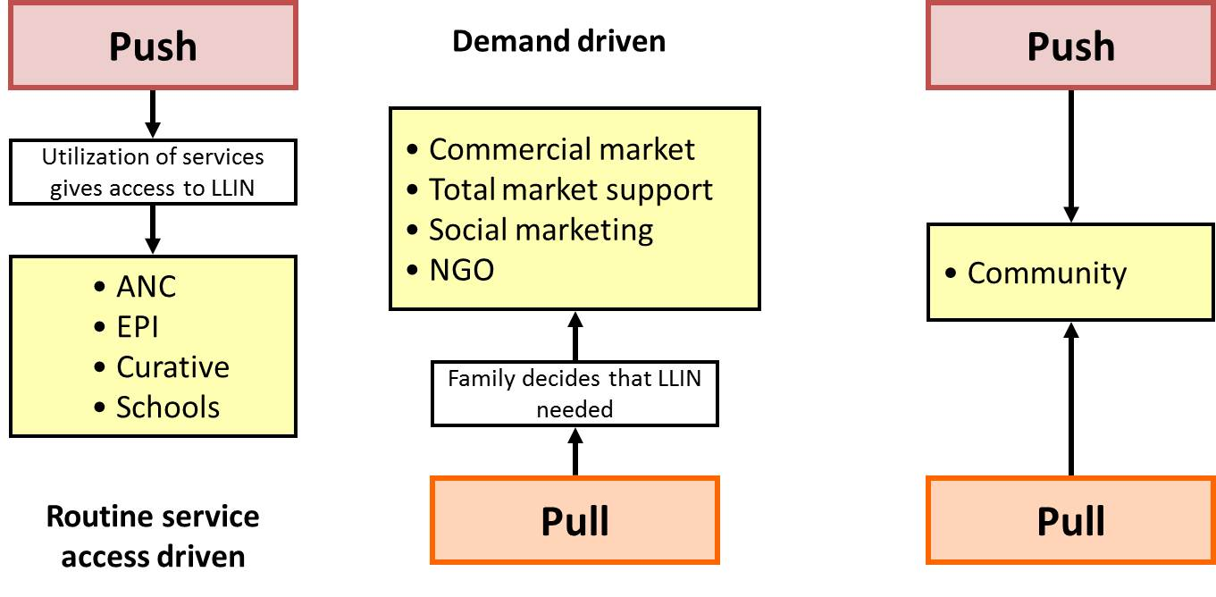
In a continuous distribution system that only has push components there is the potential danger that the push, i.e. the attendance at the services which define access to the nets exceeds the need so that more nets are given out than can be used leading to an cost-ineffective approach and nets “spilling over”, i.e. being used for other purposes than sleeping which in turn can sabotage efforts of BCC to establish a net use culture. It is, therefore, in general recommended to have at least some pull component in the mix of distribution strategies in order to have some auto-regulation and achieve equilibrium in coverage around the target (Figure 2).

Figure 2: Combining push and pull systems to avoid oversupply of the system
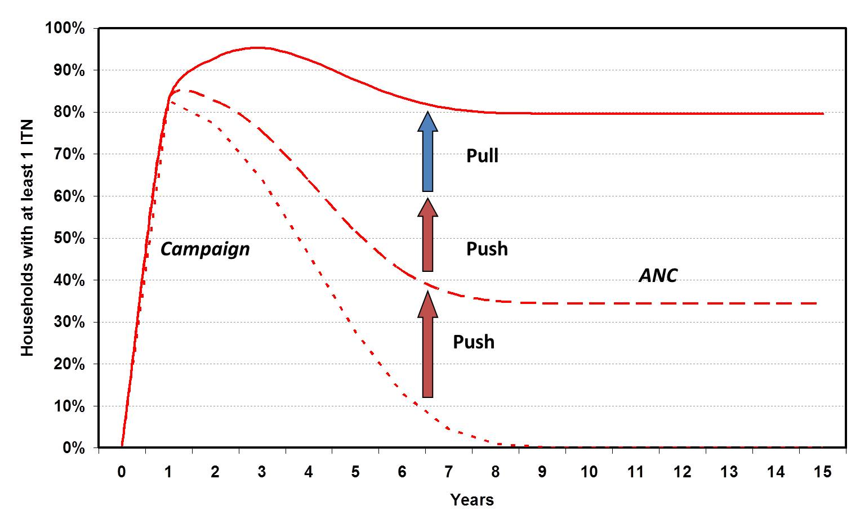

Projection of LLIN needs and options for distribution channels

LLIN needed to sustain target coverage
In order to estimate the number of nets that would be needed to sustain a defined target level of LLIN ownership at an assumed rate of loss of nets over time NetWorks has developed a tool (NetCALC) which can provide such estimates for any defined population.

Projections were made for Nasarawa State based on the 2006 census population and the growth rate reported for Nasarawa of 2.9%. These suggest that at a target coverage of 80% of households owning at least 1 LLIN and an average useful life of these LLIN of three years 350,000 LLIN are needed annually for Nasarawa except for the first few years immediately following the mass campaign when loss rates are still low (blue line in Figure 3). This number of LLIN is equivalent to about 13% of the annual population and implies that for an average ward of 20,000 people 2,600 LLIN (52 bales of nets) would be needed per year and 650 LLIN (13 bales) per quarter. If one assumes that a CDD covers 250 people the number of LLIN he would need to deliver per annum are 32 but only 8 per quarter. If, however, one CDD covers up to 2,000 people (as currently seems to be the case occasionally), the annual amount the CDD would have to distribute is 260 (65 per quarter).

Potential output of various channels
The NetCALC tool also allows an estimation of the output that can be expected of various distribution channels (routine services including schools or community or market based) and compares these with the calculated need to sustain the defined target. Using data on access to services from the 2008 DHS such projections were made for Nasarawa and results are shown in Figure 3. These suggest that even if ANC and EPI distributions are used together with school-based distributions in primary and secondary schools the target of 80% LLIN household ownership could not quite be sustained. However, if ANC distributions to protect pregnant women throughout their pregnancy were combined with a community-based distribution system (e.g. through CDD) approximately 50% of all households would need to receive a net through the community system each year and the target of 80% LLIN ownership could be sustained. In such a scenario for 2012/13 about 58,000 LLIN annually would need to be channeled through ANC and 220,000 through the CDD system.

Figure 3: Output from NetCALC for Nasarawa: light green line expected coverage from distributions; dark green diamond ITN ownership at survey; blue line need of LLIN to sustain target of 80%; red lines different continuous distribution scenarios
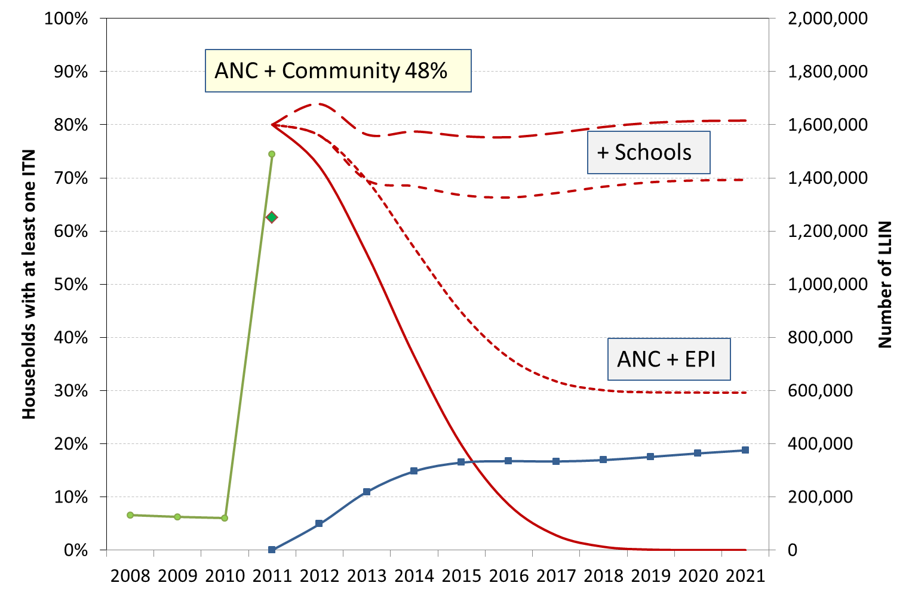

Proposed community-based distribution system

Based the findings from the initial fact finding and design mission and the subsequent discussions the following option for a community-based LLIN distribution system is being suggested.

General principles
The distribution system
- Builds on existing systems and mechanisms and support or enhance these as much as possible (integration)
- Makes adjustments where needed to take into account the specific characteristics of the nets (e.g. their bulkiness) as well as aspects of use (need for a net culture and motivation to use)
- Complements the component of ANC-based distributions as recommended by WHO and NMCP since this will guarantee that pregnant women receive an LLIN as early in their pregnancy as possible without having to wait for the next distribution period
- Is community driven requiring a pro-active role of households to initiate the process of obtaining new or additional LLIN (push-pull system)

Detailed description of distribution
The proposed approach has two separate phases:
- the push of nets to the hub which could be the health facility, the ward development committee (or similar) to be decided by each LGA
- the pull of nets from the households which have to take two active steps (supported by adequate BCC)
  - Visit their CDD and declare their need for additional or replacement nets and
  - Once given a coupon (net card) by the CDD go to their hub and redeem the coupon against a new LLIN

The flow of activities will be as follows:
- LLIN are allocated quarterly to LGA and hubs based on expected need, prioritization and LLIN availability, after the initial phase consumption vs. expected need will also be considered
- Nets and other supplies are transported to hub
- In parallel communities (and local leaders) are sensitized and reminded to select CDD where there are no currently active ones
- CDD are called for a one day training on the processes and given materials (coupon booklets, assessment aid, registers and forms)
- Communities are informed that during a given period (one month every quarter) they can approach the CDD and express their need for more nets
- CDD will visit these households and assess the need based on household members and existing, viable nets and give coupon(s). This can be combined initially with a prioritization (based on clear criteria and an assessment aid) e.g. based on size of gap in household in order to ensure settlements and families missed during campaign are served first without exhausting the net supply. Once a steady state is reached (second year) this would no longer be necessary
- Households take the coupon to the facility or ward development committee to receive their net(s)
- Supervisors meet with CDD quarterly to discuss issues, collect summary forms and issue supplies if needed
- Summary reports from CDD and hub (distribution data) are sent quarterly to LGA and State

Figure 4: Flow diagram of CDD distribution system
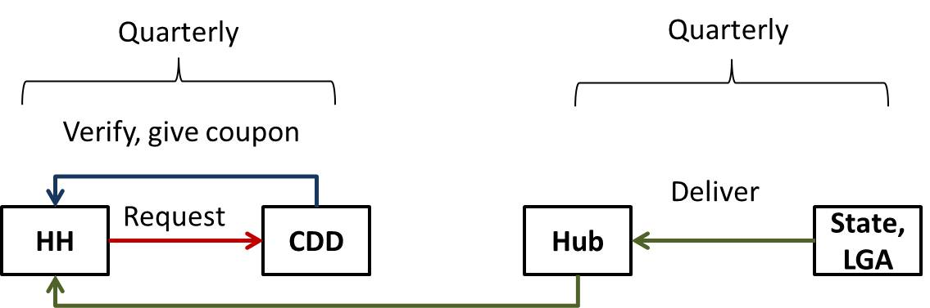

Although not directly linked with ANC distributions, both channels will complement each other and at LGA and state level output from both channels will be combine.

Implementation

Not all details of the implementation can be outlined at this point as some aspects will depend on local experience and decision. The outline presented here, therefore, is only a recommendation and guidance.

Program ownership
Ownership of the continuous distribution system by the local authorities and leaders and acceptance by the community need to be achieved in order for the system to work. This will require sufficient attention during the roll-out process to adequate sensitization as well as a sound BCC program that communicates the purpose and conditions of the distributions and stimulates the motivation to obtain additional nets when needed and use then regularly.

Quantification and allocation of nets

Allocation of nets to LGA and wards
In the initial phase of the distribution, i.e. in the first year, no consumption data will be available to base allocations on and since there is a considerable gap left behind by the campaign, the demand will be above the expected and will also vary from LGA to LGA or ward to ward.
In order to adjust the system to this challenge the first two quarterly distributions will be targeted for “filling gaps in distribution” and only thereafter will replacements be made.
The basic allocation of LLIN per LGA per each quarterly distribution will be 3.25% of its estimated population (one quarter of the 13% previously estimated in NetCALC). However, for the first two rounds the allocation will be 5.0% and special allocations can be made by the State Malaria Program based on areas of special need. For the second round allocations will be adjusted based on any possible balance left from the previous round.

Once a steady state is reached, the allocations are expected to fluctuate between 3.0and 3.5% of the current population and this figure can be used as an orientation to identify wards with un-expectedly high demand and in need of supervision regarding potential leakage of LLIN. To facilitate the net allocations and monitoring to hubs NetWorks will avail a database which will be designed once a final agreement on procedures is achieved.

Assessing need for LLIN within the household (eligibility)
Declaring a need for additional or replacement nets will be primarily the responsibility of the households. Once LLIN have been delivered to the hubs communities will be informed through various channels (see next section) and will have four weeks to contact their CDD.
Once the demand has been declared the CDD will arrange a visit to the household and will assess the following information:
- Number of usual household members (excluding visitors)
- Number of available sleeping places
- Number of available LLIN
- Whether household has any children under 5
CDD will be trained to make these assessments (e.g. definition of a sleeping place, when not to consider a net as “viable”) and will be given visual aids to identify LLIN by their label or package.
With this information the CDD will fill the assessment form and determine the number of “priority points” of the household which will depend on the existing net gap, availability of any nets and presence of children under five years. The maximum points will be five and the criteria to be eligible for additional net will vary over time: for the first two rounds of distribution only households with at least three priority points will be eligible while after that any household with at least one point will qualify. A draft assessment form for CDD is attached in the annex.
Following the assessment the CDD will give a coupon for a maximum of two nets per household and advise the household were to redeem it (health facility or ward development committee).

Mobilization and BCC

For the success of the CDD-based distribution it will be crucial that all partners are aware of it, stakeholders are adequately mobilized and potential recipients understand the criteria by which nets are allocated and that there will be repeated opportunities (every quarter) for a new net. Mobilization has to start early enough to allow those communities that do not have an active CDD to select one who then can participate in the CDD training. Local authorities as well as the ward development committees should be part of the mobilization.

BCC activities on the general promotion of ITN/LLIN use and maintenance will be undertaken by MAPS and other partners in the state. These will need to be complemented by specific messages through the CDD.

Distribution

LLIN for the CDD-based distribution in Nasarawa will come initially from USAID-PMI which has already 200,000 in stock for 2012 for CDD and ANC distributions. Supply of some LLIN in 2013 and 2014 through this source is also likely but other sources will have to be identified for long-term sustainability.

Logistics
While good logistics management is always a critical element, it is particularly important in a continuous system as trust by the recipient will only be sustained if they can expect the system to work also next time, i.e. they are certain that is not their only opportunity to get an LLIN. Points of particular importance are:
- To ensure that resources of LLIN are available in sufficient quantities to feed into the system. This will require advocating well ahead of time to obtain LLIN from various sources including the State Government. On the other hand it will be much easier to convince potential donors to invest in providing LLIN if it can be demonstrated that the system works successfully.
- Having sufficient storage and management capacity at each level where nets are to be handled based on the projected numbers per delivery interval. This may imply that in some instances the outlet for the coupon redemption is chosen to be different from the heath facility which handles the ANC distribution. This decision is to be made by the LGA health team in each case based on an initial capacity assessment.
- By undertaking quarterly distributions the demand on transport capacity is optimized but it will still be crucial to have a detailed plan in place where LGA without transport capacity are supported to pick-up the allocated LLIN from central storage and deliver them to the hubs.

Training, supervision and motivation of CDD
Following the initial training of the CDD and supervisors a schedule for supervision and refresher training will have to be made. While this will in part depend on the available resources, a minimum of one supervision visit per quarter and one re-fresher training per year is strongly recommended.

Avoiding high attrition rates for CDDs will be especially important for the continuous LLIN distribution system as the training in the net or coupon allocation is critical and experience in this process important for good performance. Increased recognition and motivation of the CDD could come from the fact that communities may value receiving nets through them more than they appreciate receiving drugs against one of the NTDs. In addition, a more regular contact with households than only once a year will further contribute to increased levels of awareness of CDDs contributions in the communities.

Nonetheless, it may also be worthwhile to consider other forms of incentives such as occasional support items such as caps of T-shirts or a transport refund when CDD come to collect supplies. While these options will depend on available funding, the discussions with the managers of the CDD program suggested that such an approach would be perceived as helpful rather than obstructive for the mass drug administration program.

Roles and responsibilities

The overall coordination of the CDD-based LLIN distribution as well as the ANC-based distributions lies with the State Malaria Program Nasarawa and the local RBM partnership.

Major implementation partner is the MAPS project which will also be supporting the BCC component.

NetWorks will support the finalization of the design and development of monitoring tools. In addition, it will provide assistance in the ongoing monitoring and undertake the final evaluation.

The Deliver project will support the logistics of the LLIN warehousing and allocation and assists in the organization of the transport to the hubs.

Monitoring and Evaluation

Success of CDD-based LLIN distribution system in Nasarawa will be measured at two levels:
- Output-based data, i.e. routine data on the numbers of LLIN distributed per CDD and/or administrative unit. Using population estimates this data source can provide “administrative coverage” estimate that can indicate trends and progress between surveys and can be complemented by modelling.
- Population based data from representative household surveys at baseline and after two years of implementation will capture the core outcomes of ownership and use as defined by the recently revised RBM recommended indicators for Universal Coverage with ITN

Routine data and their flow
Monitoring of input will follow the flow of nets based on waybills and stock cards from central level to the distribution points. The CDD will keep a record of coupons issued and at the redemption point the coupons will be collected as well as a register with confirmation by the net recipient kept.

Process monitoring will consist of the trainings and supervision activities as well as BCC interventions. Primary output data will be the LLIN distributed complemented by the number of coupons issued with the resulting redemption rates.

As much as possible existing mechanisms of reporting as part of the HMIS or Malaria Program Monitoring from the facilities to LGA and State will be used in order to minimize extra efforts and integrate as much as possible. A data base will be established at State level that will capture input/output data together with reporting completeness, estimated population (by ward) and projected need and automate the generation of tables and graphs relevant for decision making and especially flagging any discrepancies that should trigger an inquiry or special supervision.

Population based surveys for evaluation
The baseline population-based, state-representative post campaign household survey was undertaken in November 2011 and preliminary results have already been disseminated. A final report is under development.

A follow-up survey will be undertaken at the end of 2013, i.e. three years after the initial campaign distribution and after two years of CDD and ANC distributions. At this time one would expect that around half of the original nets are no longer in circulation (depending on the de-facto net survival) and household ownership of ITN would have dropped to around 35-40% without further distributions. The critical questions that the evaluation survey will need to answer are:
- Has the national target of 80% of households owning at least 1 LLIN been sustained during the two years of implementation?
- Have gaps left by the initial campaign (only 2 nets per household) been filled and the proportion of population with access to an ITN within the household been increased?
- Has this been achieved in an equitable manner, i.e. has the distribution system included the poorest sections of society?
- Is use of the nets sufficiently high in all population groups?

In addition, costing data will be collected in order to estimate
- Cost per LLIN distributed at start-up and at “steady state” of implementation in the second year.

Next steps

The next steps that will need to be undertaken are the following:

- Present the proposed design to all partners and stakeholder, adjust were needed and move towards implementation
- Start the process of micro-planning which needs to include
  - Costing and budget development and alignment with available funds from MAPS
  - Detailed plan for sensitization/mobilization, training and supervision activities with timelines (Implementation Plan)
  - Allocation of LLIN based on agreed projections and priorities
  - Development of all necessary tools such as forms, training and BCC materials, job aids, supervision checklist and coupons

Annex

CDD-Based LLIN distribution Nasarawa State
Household need assessment sheet for CDD

LGA: __________________________________ Ward:________________________________
Settlement:_____________________________ Date: __/__/______
Name of head of household: _________________________________________

Step 1: collect information

A: Number of usual household members in the household A
B: Number of sleeping places B
C: Number of existing, viable LLIN C

Step 2: calculate LLIN need and gap
D: LLIN needed for full coverage = A/2 and rounded up D
Mark the lower of the two or E if the same
E: LLIN gap = D – C E
F: LLIN gap = B – C F

Step 3: determine priority

Tick appropriate field
Gap is 3 or higher (see marked field E of F) …….. 3 points
Gap is 2 (see marked field E of F) ……………………. 2 points
Gap is 1 (see marked field E of F) ……………………… 1 point
Gap is 0 (see marked field E of F) ……………………. 0 points Gap points
Household has no viable LLIN………………………….. 1 point No nets point
Household has child under 5………..…………………. 1 point U5 point

Total priority points

Blackburn at al., 2006, Am J Trop Med Hyg, 75: 650-655

