HEALTH FACILITY DISTRIBUTION OF LONG LASTING
INSECTICIDE-TREATED NETS (LLINs) IN GHANA

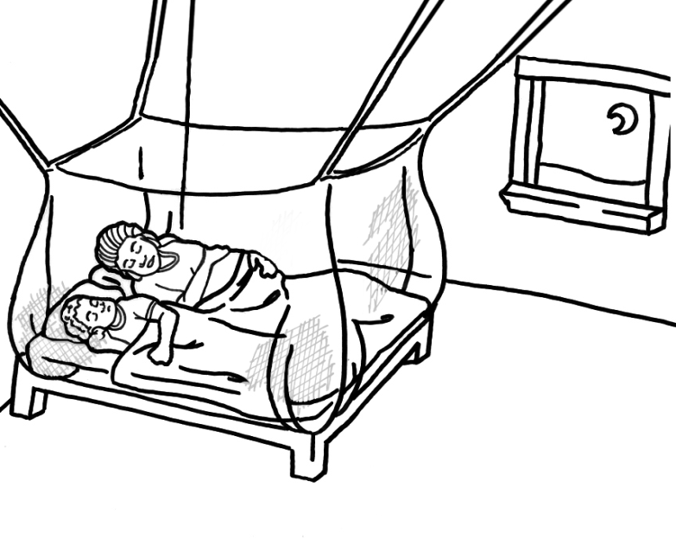

TRAINING MANUAL
(April 2015)

TABLE OF CONTENT
Background of Health Facility Distribution 1
UNIT 1: Role of LLIN in Malaria Prevention 3
UNIT 2: Continuous Distribution of LLIN 6
UNIT 3: Roles and Responsibilities for LLIN distribution 8
UNIT 4: Logistics and Supply Chain 9
Unit 5: Distribution, Record Keeping and Reporting 11
UNIT 6: Communication and Social Mobilization 12
Appendices: 18

Background of Health Facility Distribution

- Introduction
Between 2010 and 2016, about 25 million LLINs were distributed to all regions in Ghana via its mass universal coverage campaign. This campaign aimed to ensure every 2 people in a household had access to one LLIN. From 2017-18, there are further plans for another mass LLIN distribution to replace the LLIN distributed in the previous mass distribution campaigns.
Beyond the 2012 mass distributions, Ghana channelled LLIN to households on a continuous basis to help sustain coverage levels. These channels included:
• ANC (through pregnant women at their first ANC visit)
• EPI (through children receiving their 2nd measles vaccination)
• Primary Schools (through children in primary 2 and 6)
The key benefit of this continuous distribution strategy is that most of the population at risk of malaria in Ghana will be able to have uninterrupted access to nets over the long-term, and to help sustain the national target of 80% LLIN universal coverage.
For health facility-based distribution, pregnant women who visit the ANC for the first time will receive a free LLIN after ANC services are provided, to add up to LLINs available in her household. Also, if the pregnant woman does not already have a LLIN, this will help ensure that pregnant women receive LLIN and follow recommendations to sleep under a LLIN early in their pregnancy to reduce maternal and neonatal malaria morbidity and mortality. Similarly, a child receiving the measles 2 vaccinations at EPI clinic will also get a free LLIN irrespective of age of vaccination. This service will also be provided to children receiving measles vaccination during outreach clinics to communities where children are vaccinated. This will encourage guardians/ caregivers to bring their children to complete their vaccinations since they will receive a free LLIN upon primary course completion of vaccination. The LLIN received will add up to the stock of LLIN available in the recipient’s household.
For an effective health facility-based continuous distribution, it is important that health facility storekeepers and health workers in ANC and EPI clinics are well trained in: proper documentation of LLIN stocks and the processes for LLIN restocking, proper documentation of LLIN distributed to beneficiaries using the clinic registers, and reporting of monthly summaries of LLIN distribution.
This training manual outlines trainings/ orientations that are required at national, regional, district and health facility levels to ensure effective and successful LLIN distribution activities in health facilities. Depending on the level of training being conducted, the appropriate section of this guideline and its contents should be used.
- Health Facility Level Training

  - Who should conduct the trainings?
Facilitators for the training of health facility workers should include personnel from regional and district levels that were trained on health facility-based LLIN distribution. Facilitators from the national level will support facilitators from regional and district levels.

  - Who should the trainees be?
Trainees should be all health workers involved in ANC and EPI clinic service delivery at health facilities. Where available, Health facility Storekeepers should also be included in the trainees.
A draft training agenda to guide the training session is shown in Table 4 below.

Table 4: Draft Agenda for Health Facility Level Training

Session title | Duration | Time | Facilitators
Unit 1: Role of LLIN in Malaria Prevention | 15 min | 09:00 - 09:15
Unit 2: Continuous Distribution of LLIN | 30 min | 09:15 - 09:45
Unit 3: Roles & Responsibilities for LLIN Distribution | 15 min | 09:45 - 10:00
Unit 4: Logistics and Supply Chain | 30 min | 10:00 - 10:30
Unit 5: Distribution, Record Keeping, Reporting | 60 min | 10:30 - 11:30
Unit 6: Communication & Social Mobilization | 30 min | 11.30 - 12:00
AOB

Note: Training should not require more than half a day.

3.3 Training Content

UNIT 1: Role of LLIN in Malaria Prevention

Learning objectives
At the end of the session, participants will be able to:
- Describe how malaria is transmitted
- Explain the preventive tools used in malaria control
- See malaria as a dangerous disease and as a major public health problem in Ghana
- Describe the differences between ITN and LLIN
- Describe the role of LLIN in the fight against malaria in Ghana, and hence the reason for the planned activities

Questions to be addressed
- Why is malaria an important disease?
- What causes malaria and how does it spread?
- What are the effects of malaria on the community, and who are the groups of people most vulnerable to malaria?
- What are Insecticide Treated Nets (ITN) and Long-Lasting Insecticidal Nets (LLIN)?
- Why are LLIN effective in preventing malaria?
- Are LLIN safe?

FACTS
- Human beings are infected through the bite of an infective female Anopheles mosquito, meaning the female Anopheles mosquito has previously taken up the parasite from an infected person
- There are many other types of mosquitoes; some that bite in the daytime and some in the early evening. These mosquitoes do not transmit the malaria parasite
- The malaria-carrying Anopheles mosquito usually bites at night and is the only one that can transmit malaria. One can only get malaria by being bitten by infected Anopheles mosquitoes
- The environmental conditions in most parts of Ghana favour mosquito breeding all the year round resulting in transmission of malaria throughout the year
- Malaria is an acute illness caused by malaria parasites. Acute means that the illness appears and progresses very fast
- In Ghana, malaria kills more children than any other disease; most children who die of convulsions and anaemia (lack of blood) actually die of malariaMalaria is the most common cause of convulsions and loss of consciousness among children, not bad spirits or witchcraft as some people believe
- Malaria is a leading cause of abortions and stillbirths in pregnant women
- Malaria is a cause of absenteeism at school and affects children’s IQ
- Families lose a lot of money not only on treatment of the sick but also on transport to health facilities. They also lose a lot of time meant for gainful work
- Pregnant women and children under five years of age are most vulnerable to malaria. Malaria is most dangerous in these groups of people and can result in death
MYTH
- One can get malaria by eating mangoes or maize, drinking dirty water, or walking in the rain. Many people believe this because malaria is most common during the rainy season, when mangoes and maize are plentiful. Actually, the reason that there is more malaria when it rains is because there are more breeding sites for the malaria transmitting mosquitoes.

Fortunately, the mosquitoes transmitting malaria bite mainly during the night. This makes the mosquito net an excellent tool to prevent malaria if it is used properly every night.

ITN and LLIN
- Insecticide-Treated Nets (ITN) are mosquito nets that are treated with a safe insecticide
- The protection that mosquito nets provide against malaria is doubled when the net is treated with insecticide because the net kills/repels mosquitoes in addition to stopping them from reaching and biting the person.
- Conventionally, nets were treated by dipping them in an insecticide solution - and to ensure its continued insecticidal effect, the net had to be re-treated at least once a year because the insecticide washes off quickly
- In contrast, Long Lasting Insecticidal Nets (LLIN) is a type of ITN which does not need to be re-treated if handled with care. LLIN are factory-treated mosquito nets made with netting material that has insecticide incorporated within or bound around the fibres. The insecticide on the net lasts for the lifetime of the net (usually 3 years or 20 washes)
- All nets distributed at health facility are LLIN
- The insecticides used for ITN and LLIN are approved to be safe by the World Health Organization (WHO) and the Ministry of Health

Take Home Messages
Communicate these in a participatory manner, posing questions to the audience etc.

- Malaria is the number one killer disease and cause of fever in Ghana
- The malaria carrying mosquitoes bite mainly at night and indoors
- The good news is that malaria is preventable by sleeping under a LLIN every night
- The LLIN do not need retreatment
- The insecticide in LLIN is safe. This has been approved by the Ministry of Health in Ghana and the World Health Organization
- These nets are distributed to all pregnant women visiting ANC for the first time and children receiving the measles booster (measles 2) vaccine

UNIT 2: Continuous Distribution of LLIN

Learning objectives
At the end of the session, participants will be able to:
- Explain the LLIN continuous distribution strategy
- Describe the key channels that are part of Ghana’s LLIN continuous distribution strategy
- State the key target beneficiaries of the various channels
- State the main objectives of continuous distribution

Questions to be addressed
- Why LLIN continuous distribution?
- What are the objectives of the LLIN continuous distribution strategy?
- What are the key selected channels?
- How are these channels to be implemented?
- When is this LLIN continuous distribution strategy starting?

Why LLIN Continuous Distribution?
- Previous malaria prevention strategies aimed for high ownership and use of LLIN by vulnerable groups (children under 5 years of age, and pregnant women)
- More recently the goal has shifted to “Universal Coverage (UC)” where every person in a malarious region sleeps under an LLIN. Operationally, UC= 1LLIN to 2 people in a household

- At the end of 2012, Ghana delivered 11 million LLIN to households through its universal coverage mass campaign. After this mass campaign:How can populations not reached by the mass campaigns be served?
- How can new household members (new births etc.) be covered with LLIN?
- How can we sustain the high coverage achieved through the mass campaigns?

To ensure that populations not served are reached, new household members are covered, and to help sustain the high coverage after the mass campaign, Ghana’s aim is to continuously make LLIN available to households through the channels below.
- ANC (targeting pregnant women at their first ANC visit)
- EPI (targeting children receiving their 2nd measles vaccination)
- Primary Schools (targeting children in primary 2 and 6)

To complement these ‘push’ channels above, the additional ‘pull’ channels below will also be instituted to reach persons or households that cannot access LLIN through the channels above:

- Sales of LLIN to students in secondary schools
- Open retail sales of LLIN in urban and peri-urban areas
- NGO, CBO and FBO distributions at the community level
- Workplace programs to encourage employer purchase of LLIN for among employees

What are the objectives of the LLIN continuous distribution strategy?

- Provide LLIN for replacement and “add-on” to sustain “universal coverage”
- Avoid oversupply (spill-over) by combining “push” and “pull” systems
- Use the household as entry point for LLIN with intra-family or intra-community redistribution based on need
- Utilize all suitable channels with combinations of free, subsidized and at cost nets where possible

What are the key channels?

- Ante Natal Clinic (ANC) - Pregnant women attending Ante Natal clinic for the first time
- Child Welfare Clinic (CWC) - Children due for measles 2 (Booster dose) vaccine
- School-based distribution - Pupils in Primary 2 and Primary 6

UNIT 3: Roles and Responsibilities for LLIN distribution

- Learning Objective
At the end of the session, participants will be able to:
- Identify and perform specific roles assigned to all persons involved in the LLIN distribution as follows:

Organisation/ Person | Responsibilities
Health Facility Level
Nurse In-charge of ANC & EPI clinics | - Requests and monitor LLIN stocks received from health facility store for ANC and EPI distribution  - Supervises LLIN CD implementation at ANC & EPI clinic, and ensure that all health workers are properly oriented on LLIN CD processes  - Collate, review and validate LLIN distribution data from ANC and EPI clinic  - Enter validated LLIN distribution data into the monthly LLIN distribution summary form for submission to district
ANC & EPI Clinic nurses | - Register pregnant woman on first visit and child receiving measles vaccine and properly document LLIN given into clinic register and on ANC and road to health cards  - Educate recipients about malaria prevention, proper net use, care and repair
Health Facility Storekeeper | - Receive, monitor and manage LLIN stocks for health facility  - Receive requisitions for LLIN from In-charges and reviews inventory control cards from ANC and EPI clinic  - Supplies ANC and EPI clinic with LLIN stock  - Report LLIN stock outs and losses to the district

UNIT 4: Logistics and Supply Chain
- Learning Objectives
At the end of the session, participants will be able to:
- Describe pipeline for health facility-based LLIN distribution
- Describe the agreed threshold levels for LLIN stocks at health facility
- Explain the LLIN stocking and restocking process for health facility

LLIN Stocking and Restocking
Ordering for LLINs at all levels will be done using the existing ordering forms for health commodities. The supply chain for LLIN to health facilities for continuous distribution through the ANC and EPI channels will follow the same procedures as for all other commodities supplied by the Central Medical Stores.

Initial LLIN supply required per health facility, and districts will be quantified as follows:
• Considering the available DHIMS data for the past 2 years, average annual attendance for ANC first visit and measles 2 vaccination will be used to quantify average annual LLIN need per health facility
• These LLIN quantifications will be submitted to the district authorities (District Director of Health Services, District Malaria Focal Person, District Public Health Nurse, and District Health Information Officer) through the sub-district authorities for validation and aggregation at district level for all health facilities in each district. This will then be submitted to the regional authorities
• Information on stocks of LLIN required for each region will be calculated based on aggregated quantification from all districts within the regions. Regional initial LLIN stock quantifications which will then be validated and approved by the regional authorities (Regional Director of Health Services, Regional Malaria Focal Person, Regional Public Health Nurse, and Regional Health Information Officer) and then submitted to the National Malaria Control Program (NMCP) and its partners for validation. The aggregated quantification will form the region’s annual LLIN need. From this data, an initial 1-year LLIN stock for each region will be derived
• The NMCP will then submit approved initial LLIN stock quantifications to the Central Medical Stores for supply. Central Medical Stores will supply all District Stores with the approved 1-year district level supply of LLIN. Documentation of LLIN supplied to each region will be made available to the national level authorities accordingly
• Districts will supply all health facilities with an initial 3-month LLIN stock based on health facility ANC and EPI records as described above. Stocks of LLIN will be monitored at District Stores and health facility level using Stock Cards

Restocking of LLIN (to initial stock levels) at District and health facility level will be done based on LLIN distribution/ consumption data at these levels and this will be done based on an agreed threshold/ minimum LLIN stock at each level as in the table above. To enable restocking the following will be done:

Health facility level restocking
- All health facility In-charges will tally the number of LLIN distributed at ANC to pregnant women at first visit using the Midwives Monthly Returns Form (Form A) (Appendix ?) and at EPI clinics to children receiving measles 2 vaccine (static and outreach) respectively each month on the Monthly Vaccination Report Form (Appendix 7) , and submit this information along with other required information on service delivery to the district authorities. LLIN distribution reported at health facilities will be validated periodically by district level authorities
- Health facility LLIN restocking will be done based on the LLIN distributed and stock balance available at health facility level as reported on the Inventory Control Cards for LLINs . Health facilities will submit a requisition through the usual Ghana Health Service requisition procedures to the District Store, and will be resupplied to their ‘initial 3-month stock level’ with LLIN stock when they reach or are near their ‘1-month threshold level of LLIN stock’

Unit 5: Distribution, Record Keeping and Reporting

- Learning Objectives
At the end of the session, participants will be able to:
- Describe process of LLIN distribution at ANC and EPI clinic
- Explain the documentation process for LLIN distributed at ANC and EPI clinic
- Describe process of reporting of LLIN distributed to district level

During a pregnant woman’s first visit to the ANC:

- Health worker should go through all the usual steps for ANC ‘registration’ and record all the required information in the ANC register
- Health worker should educate the pregnant woman on the causes of malaria, malaria prevention, and the proper use and care of LLIN
- Health worker should provide LLIN for the pregnant woman and record the receipt of LLIN in the facility’s ANC register using the ”ITN Distributed” column, and the clients maternal health record card - LLIN given/date.
- Pregnant women who are unable to receive their LLIN due to stock out or any other reason at their first visit will be supplied as and when LLIN are available.

Similarly, when a caregiver/ guardian brings her child to the static or outreach EPI clinic for measles 2 vaccination:

- Health worker should go through all the usual steps for routine immunization and record all the required information in the EPI register
- Health worker should educate the caregiver/ guardian on the causes of malaria, malaria prevention, and the proper use and care of LLIN
- Entry is then made in the EPI register (12-23months) under the remarks column which captures ITN use
- Nurses record the receipt of the LLIN in the child welfare booklet, recording “Net given/[date]/[location]”.
- Health worker inform the caregiver who is unable to receive LLIN due to stock out or any other reason at the time of the child measles 2 vaccination to return for LLIN when available.
- Nurses record the receipt of the LLIN in the Health Facility’s EPI Tally Sheet

At the end of each month, the total number of LLIN distributed in the ANC and EPI clinic (both static and outreach) should be correctly tallied on the Monthly Midwives Returns Form A and the Monthly Vaccination Report Form (Appendix 7) for each channel. The Health Facility In-charge will submit this report to the District Disease Control Officer and District Health Information Officer.

UNIT 6: Communication and Social Mobilization

Learning objectives:
At the end of the session, participants will be able to:
- Explain the benefits of using LLIN
- Describe strategies to promote and influence the correct use of LLIN among beneficiaries
- Explain ways of preventing leakage of nets
- Explain possible ways of communicating malaria information to children
- Explain social mobilization plan - including community/ parents involvement

Issues to be addressed are:
- The role of health workers vigilance to prevent leakage
- The importance of promoting proper use of LLIN
- Frequently asked questions about LLINs that may help provide information to support proper use
- Mobilisation for support from communities

Please write the objectives and questions to be addressed on a flip-chart. Ensure the session addresses them.

IEC/BCC activities
Counselling/Talk sessions provides a good platform to talk about key issues related to net use and should be linked to the IEC/BCC materials that will be distributed and displayed at health facilities tailored to emphasis malaria issues to reinforce messages and effect behaviour change.

Regarding leakage, stress that:
This routine ANC/CWC distribution is to support the earlier LLIN campaign and will result in protecting the entire community from malaria only if the LLINs actually reach the people they are intended for, are not sold, and are used by the pupils (and their family members where necessary) who receive them.

Two things are important for this:
- LLINs are not stolen or diverted at any level.
- Recipients of the LLINs actually sleep under the LLINs every night.

Key messages for LLIN beneficiaries
It is important that the same messages are delivered through multiple channels, this provides reinforcement of the messages in different ways the beneficiaries can relate to: seeing, hearing, doing, repeating the cycle. For example, seeing a poster about how to hang an LLIN properly, hearing a radio spot that talks about the benefits and importance of sleeping under an LLIN, especially among beneficiaries, in an LLIN hanging demonstration. Over and over—the messages echo through word of mouth, throughout the school/ communities, and the cycle repeats itself.
Facts about Malaria:
- Mosquitoes transmit malaria
- The malaria-carrying female Anopheles mosquito usually bites at night and is the only one that can transmit malaria
- Malaria is serious, and it can be fatal
- Children under 5 and pregnant women are most vulnerable
- Malaria transmission occurs year-round
- You can prevent malaria in your home
- There is an effective treatment for malaria
- LLINs are an effective means of malaria prevention and control
- LLINs are safe for the general population, including children under 5 and pregnant women
- LLINs must be used every night

Actions:
- Acquire an LLIN
- Sleep under an LLIN every night

Benefits of LLIN:
- LLINs protect all populations at risk from malaria
- LLINs protect the pregnant woman and her unborn baby from malaria
- LLINs protect the pregnant woman from anaemia
- The child will not be born small or sickly, since the mother’s use of an LLIN helps prevent her and her child from contracting malaria
- It will ensure that the pregnancy goes to full term
- LLIN prevents school absenteeism due to malaria

Why is malaria prevention important?
- In Ghana, malaria kills more children than any other disease; most children who die of convulsions and anaemia (lack of blood) have actually died of malaria
- The most common cause of convulsions and loss of consciousness among children is malaria and not bad spirits or witchcraft, as some people believe
- Malaria is a leading cause of abortions and stillbirths in pregnant women
- Families lose a lot of money not only on treatment of the sick but also on transport to health facilities. They also lose a lot of time meant for gainful work
- Pregnant women and children under five years are most vulnerable (malaria is most dangerous in these groups of people and often result in death). Even when a pregnant woman feels healthy, malaria infection in the placenta can harm the development of the baby
- Repeated malaria infections can harm the growth and development of children
- Malaria causes children to miss days at school
How does the LLIN work?
- The LLIN works as a physical barrier to some extent, but that is not all it does. Because it has insecticide, it gives double the protection than an ordinary net with no insecticide. The insecticide on the net repels the malaria mosquitoes or kills them when they land on the net while trying to bite the person sleeping inside
- Since the malaria transmitting mosquitoes bite at night, the net is very useful at protecting people who are usually asleep at this time (underneath the LLIN)

What types of nets are distributed?
- The types of nets going out in this school distribution exercise are Long Lasting Insecticidal Nets (LLINs)
- The insecticide in these nets lasts for the lifetime of the net (usually 3 years or 20 washes, whichever comes first) so they do not need to be re-treated

Why can I still see mosquitoes around my LLIN?
- A common complaint is that people still see mosquitoes, even when they are using a net treated with insecticide. It is very important to understand that even if you see mosquitoes you are still being protected from malaria
- Even if you still see mosquitoes in the house and you even see some resting on the net and not being killed, you may be seeing a type of mosquito called Culex mosquitoes that DO NOT carry or transmit the malaria parasite. The insecticide will still be keeping away and killing the Anopheles mosquitoes that do carry malaria

How do I hang the LLIN?
- For rectangular nets, use the four loops on the net to tie the net up. You can hang it in many different ways, whatever works well for your sleeping place. You might use sticks attached to the bed at each corner and hang the net from these. Or, you might hang it from the wall or ceiling – you could hang it from nails sunk in the walls, on strings or poles
- that you can run across your room. Or you might find another solution for hanging it that works better for your space
- For conical nets, hang the net to the roof directly above the centre of the bed
- Lower it to cover the users every night and tuck the edges of net under the mattress or sleeping mat so no mosquitoes can sneak in
- Lifting up the net in the day time can help prevent it from being snagged and/or torn (if a net is accidentally torn, it can easily be repaired by sewing up the hole – and the net will work effectively, just as before)

Who should sleep under this net?
- Ideally, everyone in the family should sleep under an LLIN every night. More than one person can share the net. If for some reason there are not enough nets in the house to cover everyone, then you should at least make sure that the beneficiary and younger sibling sleep under a treated net, every night

When should the LLINs be used?
- The LLIN should be slept under every night, all year round
- There are times when you might see fewer mosquitoes around but they never disappear completely so it is important to still use the nets even at these times. It only takes one female Anopheles mosquito to catch malaria

Are young children safe under an LLIN?
- Yes. Young children are very safe under a treated net. The amount of insecticide used to treat a net is so little that it cannot harm people sleeping under the net, including babies

Are pregnant woman and unborn babies safe under a LLIN?
- Yes. The insecticide is not at all dangerous for pregnant women or to the unborn babies
- In fact, they will be extra safe under the net. The net will protect the mother throughout the pregnancy from getting a malaria infection which could hide in the placenta and stop the baby from growing properly or even cause a miscarriage
- It is important that a pregnant woman sleeps under the net throughout the pregnancy and does not save the net until the baby is born

What about the side-effects people get from new unopened LLINs?
- Side effects from LLINs are rare and not serious. They will only last for a short while if they do occur
- This effect may be (sneezing, sore eyes, itching skin, and burning sensation) and may come from freshly opened net packages. New nets should therefore be aired for a day or two to avoid these side effects. These nets are LLINs and so do not need retreating
- To be sure to avoid any side effects, the new nets that are handed out should be aired for a day before use; this will allow any excess build-up of insecticide to disperse. It should be stressed that this is only for one or two days after which the LLIN should be hung over the sleeping place and used

How should I care for my LLIN?
- The net fabric can get dirty, tear or burn like any cloth. Avoid closeness to open fires such as candles
- If you would like to wash it when it gets dirty then do so. Do not use strong detergents or bleach, as this will cause some of the insecticide to come off
- The insecticide in the LLIN only lasts for 20 washes
- Dry the nets in the shade (out of direct sun-light) after washing
- If holes appear in the net due to wear and tear, just sew the holes up as you would do for any other fabric. This will ensure that the net lasts up to the intended lifetime

Aren’t LLINs a fire risk?
- LLINs give no more risk of fire than any other cloth hanging in your house
- The chemical does not make the net any more flammable than any other fabric
- In fact, the nets are treated so that if they do catch fire the flames quickly die out
- Of course, it is important to be careful with open flames near the nets - just as you would with open flames near any other things hanging in your house. Keep the hanging net well away from open flames

Are there any other benefits of the LLINs apart from protection against malaria?
- Yes; insecticide treated nets can sometimes kill other domestic pests (fleas, lice, bedbugs, cockroaches) that come in contact with the net
- Yellow fever is also another serious disease that is transmitted by mosquitoes. LLIN can therefore help protect you from other mosquito-borne illnesses

Take-home messages
What to do to ensure LLIN are taken up and used by the targeted group?

- Every pregnant woman attending an ANC for the first time will receive 1 LLIN
- Every child due for measles 2 (booster dose) will receive 1 LLIN
- Ensure beneficiaries ANC and CWC cards and other available record books are completed multiple uptake by beneficiaries
- Health workers should not take money from beneficiaries before an LLIN is given
- Use available forums to discuss benefits of LLINs:
- Correct use of LLINs all year round reduces frequency of malaria illness in the household
- As a result, expenditure on malaria treatment and travel to seek treatment, and general workdays lost is reduced
- The above savings can be put to better use such as used for family development resulting in better living standards
- Children can attend school regularly and not miss lessons

- The importance of being responsible with the LLINs and not selling them on

- LLINs are strictly for pregnant women attending first ANC and children due for the measles booster dose

Appendices:
Appendix 1: ANC Register

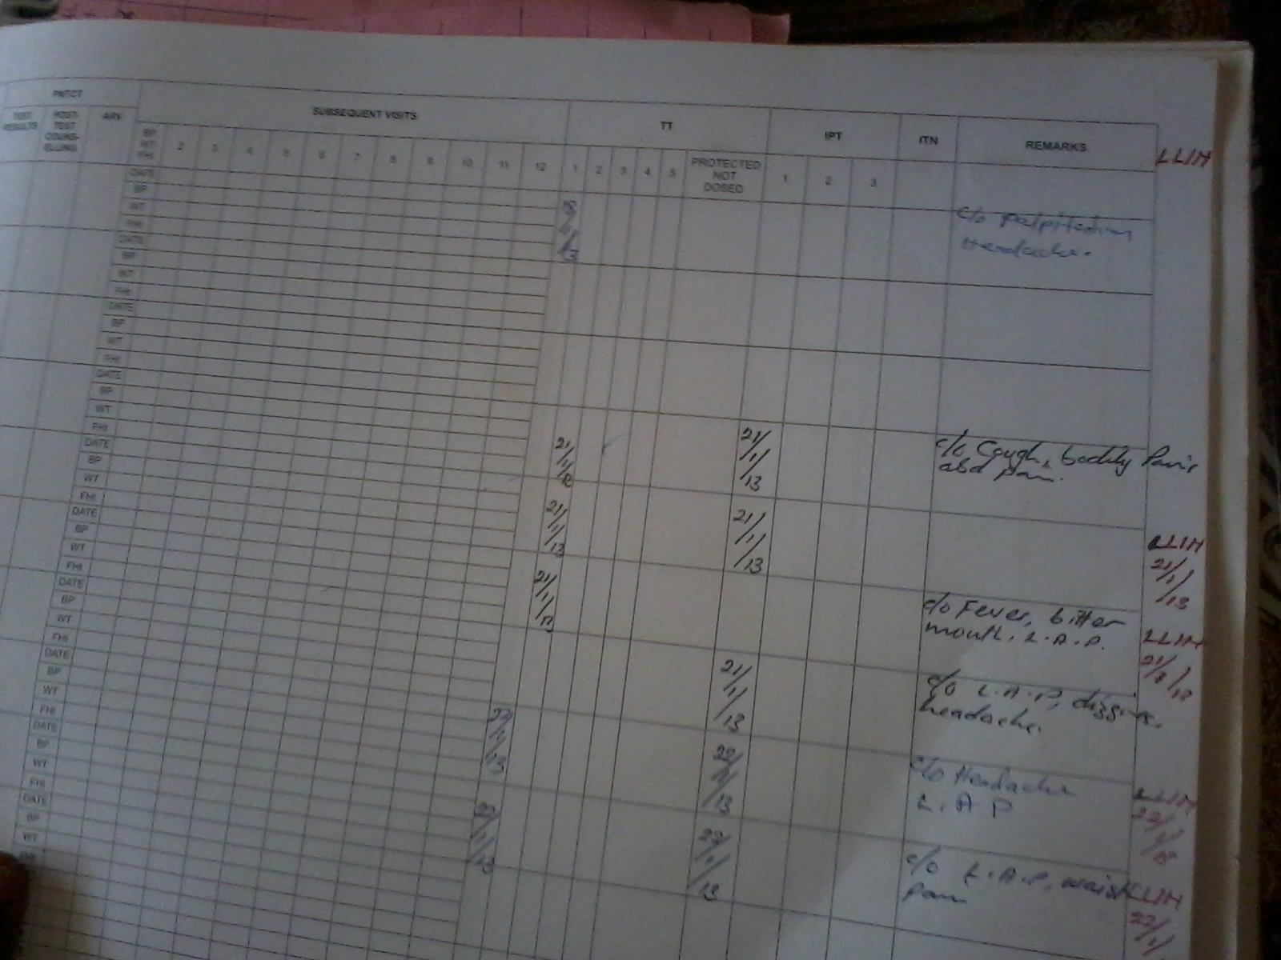

Appendix 2: Maternal Health Records Book
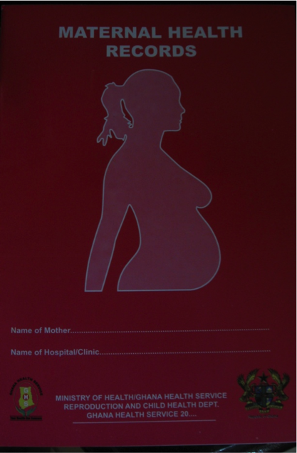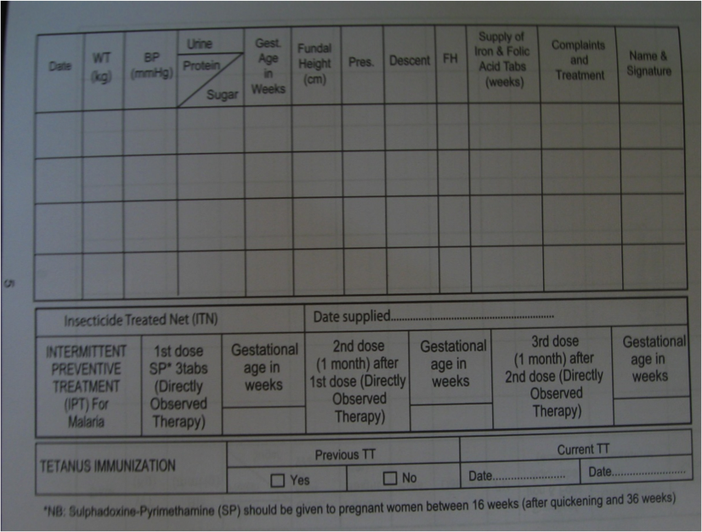

Appendix 3: EPI Tally Sheet
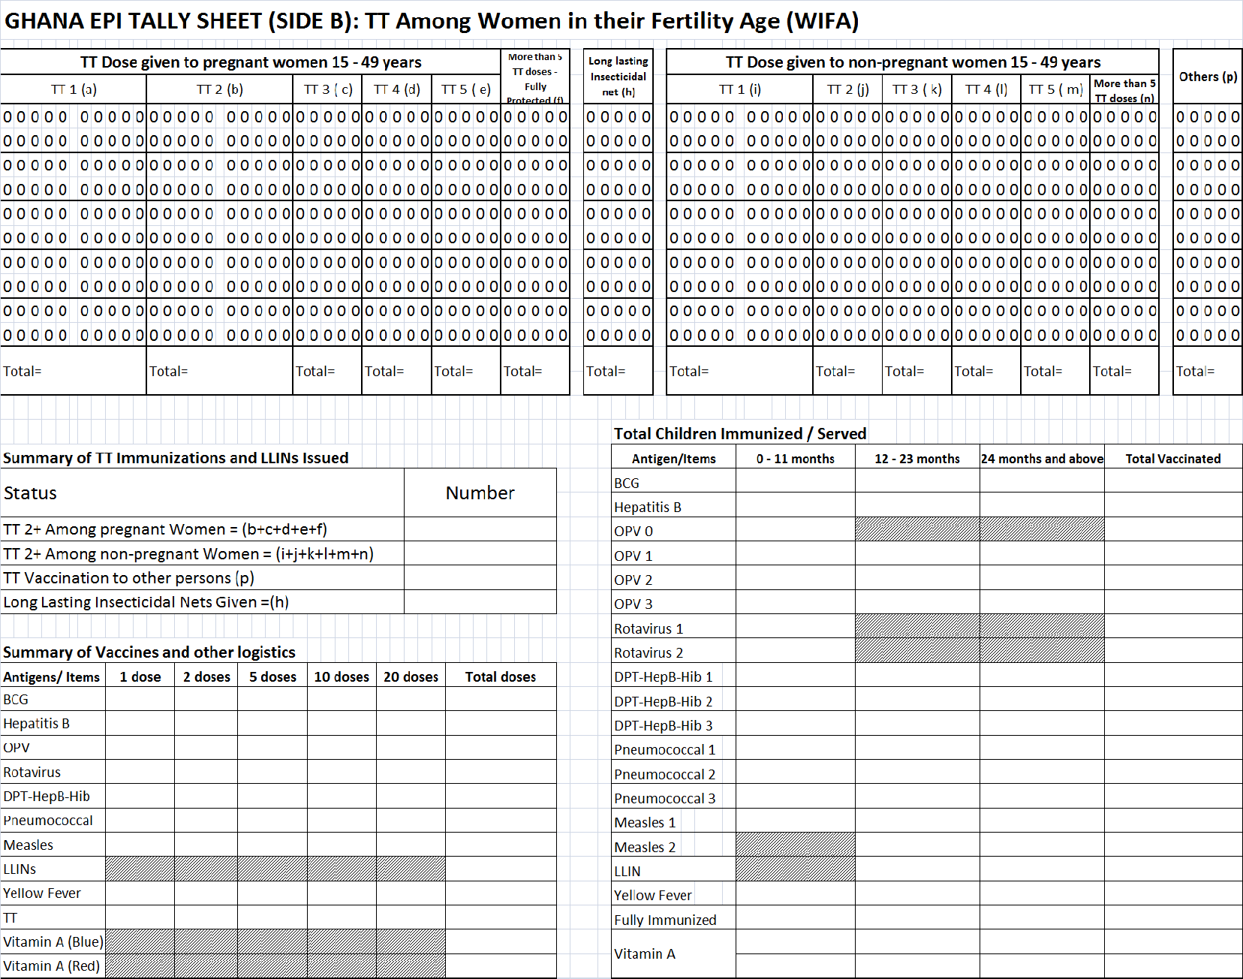

Appendix 4: Child Welfare Clinic Register

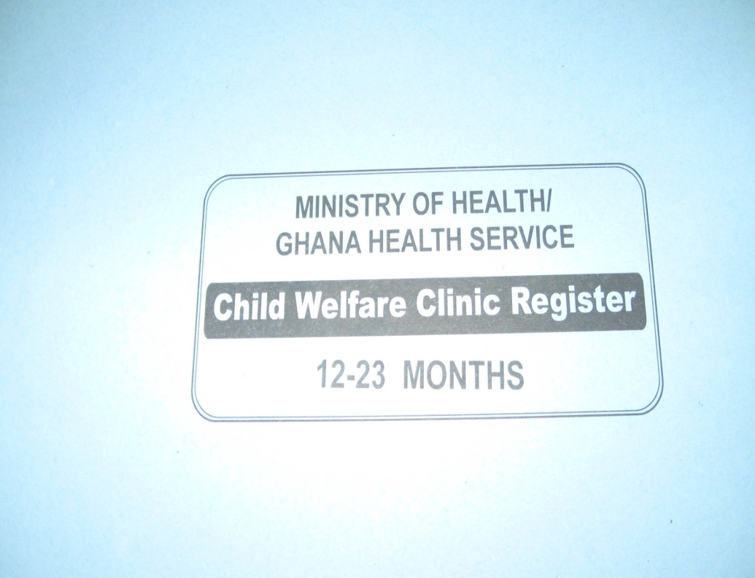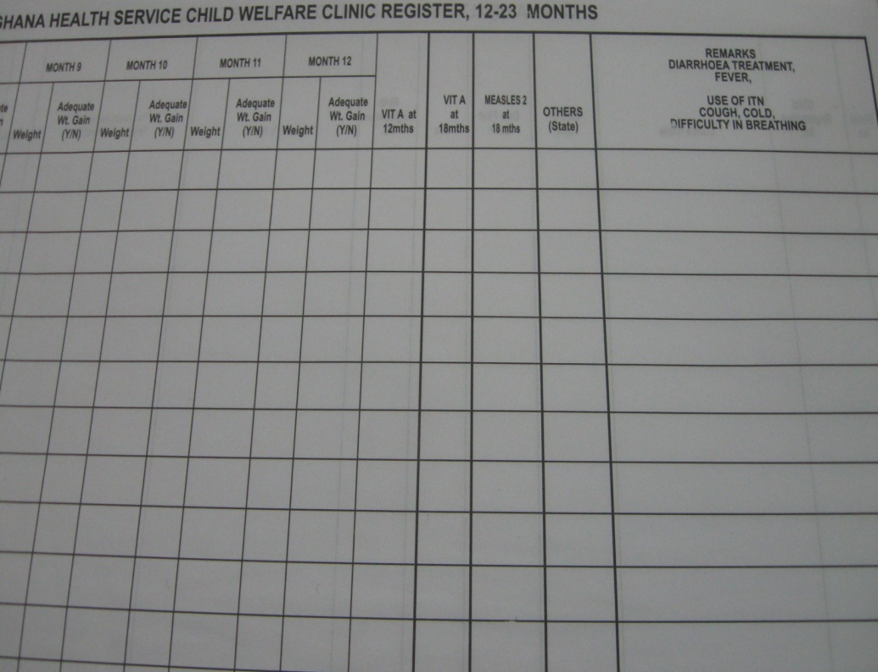

Appendix 5: Child Health Records

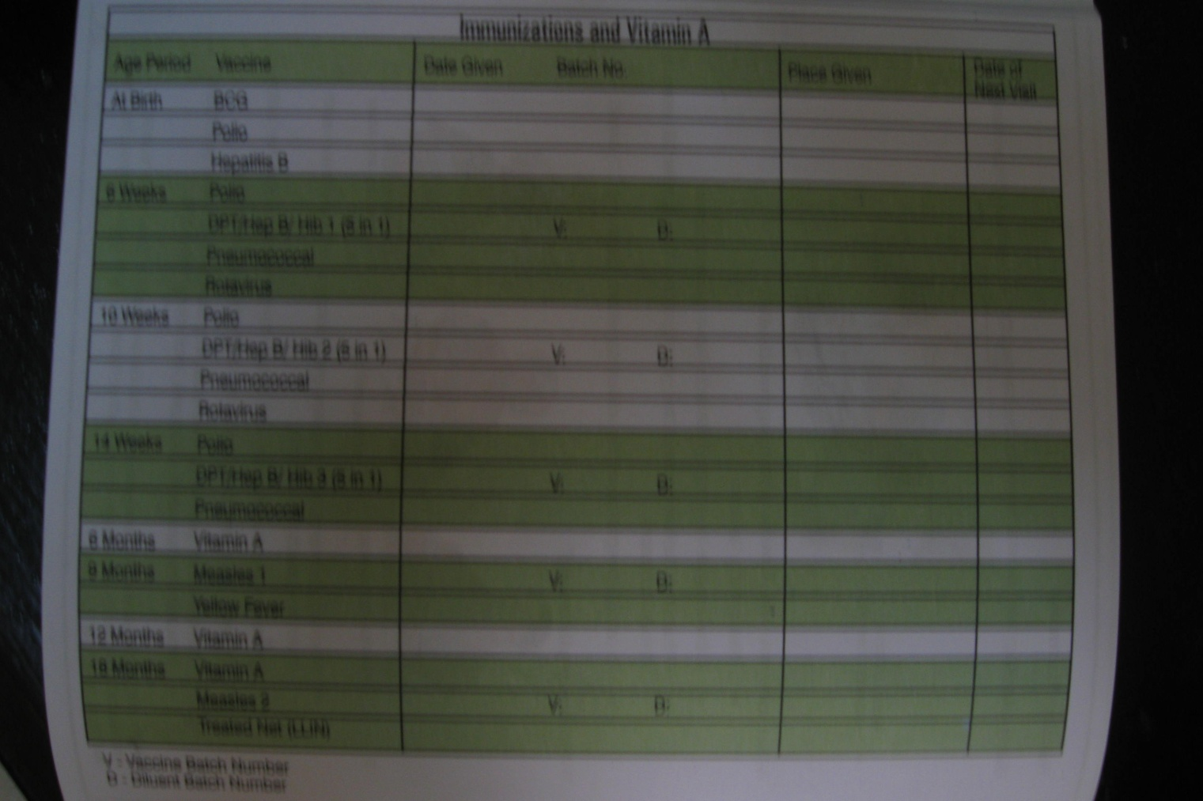

Appendix 6: EPI Tally Sheet

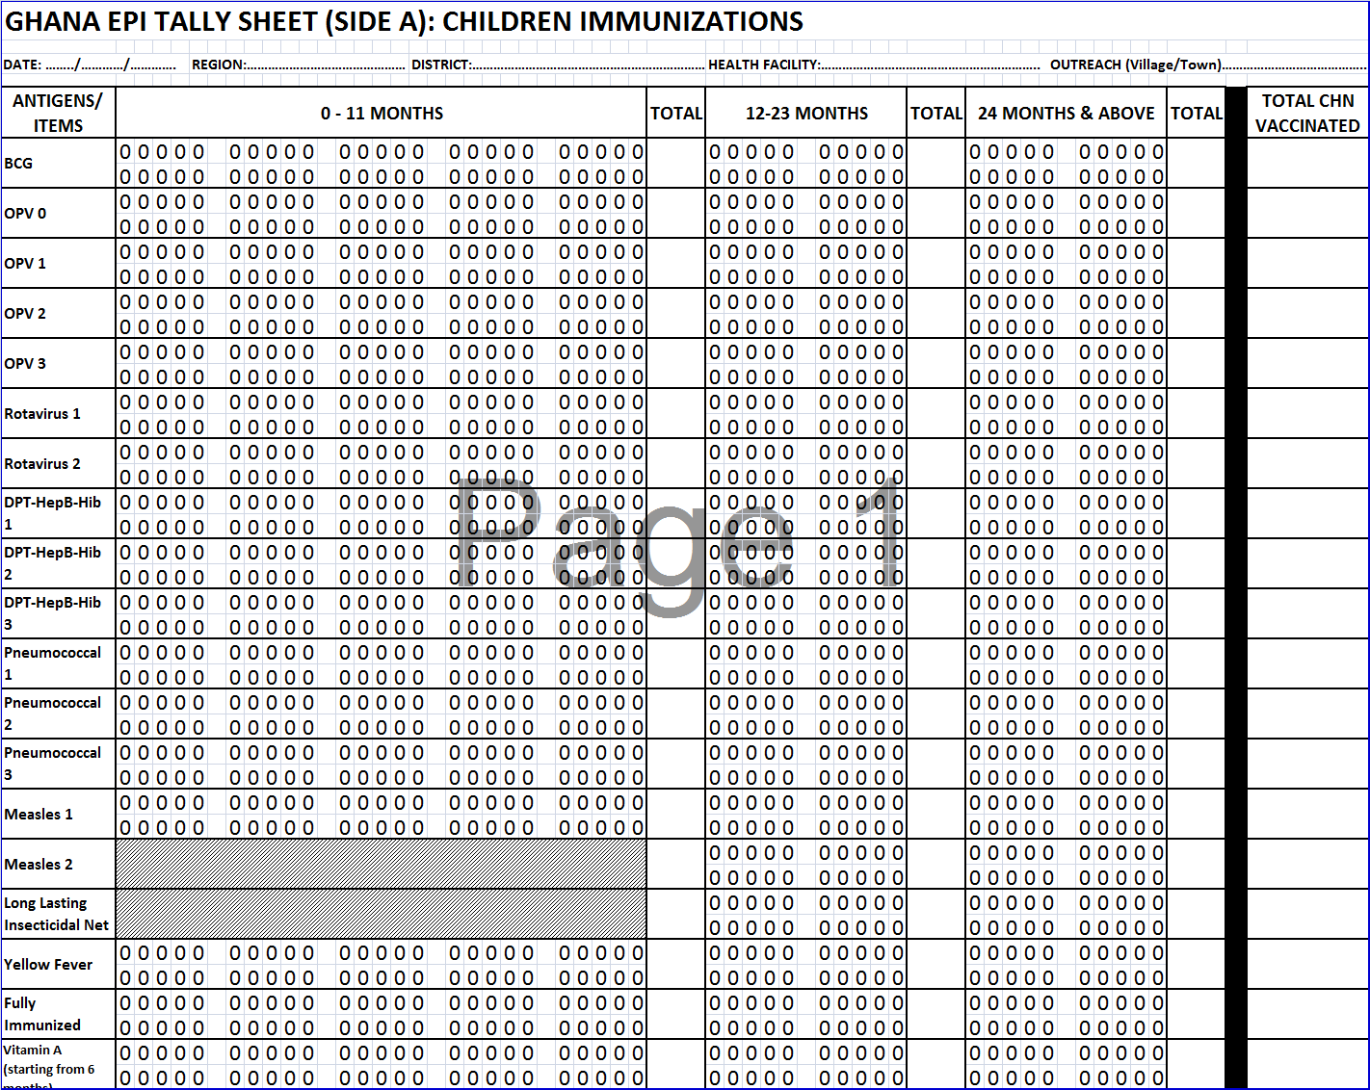

Appendix 7: Monthly Vaccination Report

Appendix 8: Continuous Distribution of LLINs Documentation Guidelines
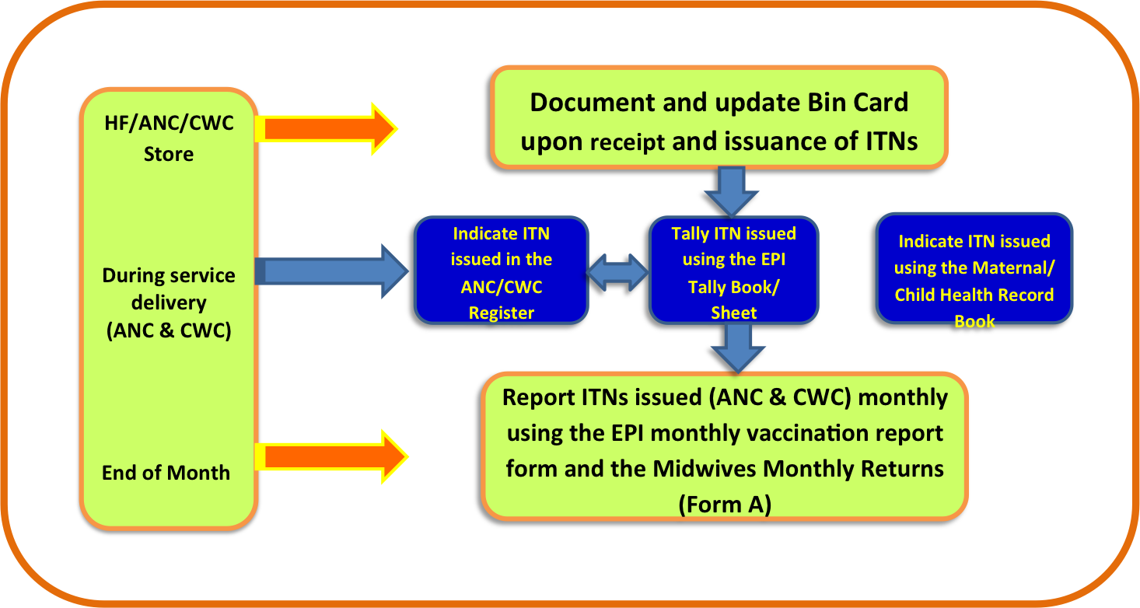

Appendix 9: Health Facility Supervision Checklists for LLIN CD in Health Facilities

CHECKLIST FOR MONITORING OF LLIN DISTRIBUTION IN ANC/EPI CLINICS
(One (1) form to be filled for each health Facility)
Region: …………………………………………………………………………………………………………………District: …………………………………………………..

Name of Health Facility: ……………………………………………………………………………………Outreach: …........................... ..... .... ..... .....

Unit (please tick): ANC: EPI Clinic: Date: ……../………/……………………….

ANC In -Charge ……………………………………………………………………………………..Con tact No. …………………………………………Pre sent: Ye s/No

EPI In -Charge ……………………………………………………………………………………….Con tact No ………………………………………….Pre sent: Ye s/No

Other Persons Met (ANC) ……………………………………………………………………..Con tact No. ………………………………………

Other Persons Met (EPI ) ………………………………………………………………………Con tact No. ………………………………………

1. Service Data
Check, record and discuss data on LLIN Distribution for the LAST THREE months

Month | Target Beneficiaries |  | Number of LLINs issued in this Facility |  | Number of LLINs Issued as Reported in the DHMS Software |  | Does LLINs issued to beneficiaries correspond with available records on target beneficiary? Indicate Yes or No
Month | ANC  (Registrants) | EPI  (Measles 2) | ANC | EPI | ANC | EPI | ANC | EPI

Service data 1.1-1.4:
Ask the following and mark all that apply for both ANC and EPI
 |  | 1.1 Are LLIN issued to beneficiaries documented in ANC/EPI register? (Inspect ANC/EPI register)
 | 1.2  1.3  1.4 | Are LLIN issued to beneficiaries indicated in the ANC Card/Road to Health Card? (Inspect available maternal/child health record book)  Are LLIN issued to beneficiaries tallied using the EPI tally booklet? (Inspect EPI Tally Book)  Are LLIN issued to beneficiaries documented using the Monthly Vaccination Report and Midwife Returns Form A (Inspect report)
 | ANC |  |  |  | EPI
 | Yes always |  | Yes sometimes | No | Yes always | Yes sometimes | No
1.1
1.2
1.3
1.4

General observations and Comments ……………………………………………………………………………………………………………………………………………………………………………………………………………………………………………………………………………………………………………………………………………………………………..
2. Logistics Management

 | ANC |  | EPI
 | Yes | No | Yes | No
2.1 Is there an Inventory control card available for tracking LLINs?
2.2 Is the Inventory control card for LLINs updated as of today?
2.3 Are facilities keeping to the threshold for minimum stock levels?
2.4 What is the physical count of LLINs in stock at this facility as of today?
2.5 What is the quantity on hand of LLINs recorded in the Inventory card as of today?

2.6. Where will this facility receive its next s up ply of LLI NS?
Facility Store District store Other (Specify)……………………...

General observations/Comments:
………………………………………………………………………………………………………………………………………………………………………………………
………………………………………………………………………………………………………………………………………………………………………………………………………………………………………………………………………………………………………………………………………………………………………………

3. ANC/EPI Education on Malaria and LLINs
 | ANC |  |  |  |  |  | EPI
 | Yes always | Yes  Sometimes | No | Not observed | Not applicable | Yes always |  | Yes  Sometimes | No | Not observed | Not applicable
3.1 Are target beneficiaries given education on malaria, LLIN use and care before LLINs are given out?
3.2 Was there a demonstration on how to hang the net before LLIN is given out?
3.3 Was the demonstration done accurately?

ANC:
3.4 How are beneficiaries educated?

Group Talk One -On -One Both Other Specify

3.5 Are there job aids to facilitate education on malaria, LLI N use and care? Ye s No

3.4. I f Yes, Specify the job aids available__________________________________

EPI:
3.4 How are beneficiaries educated?

Group Talk One -On -One Both Other Specify

3.5 Are there job aids to facilitate education on malaria, LLI N use and care? Ye s No

3.4. I f Yes, Specify the job aids available__________________________________

Observe the process and provide comments:
…………………………………………………………………………………………………………………………………………………………………………………
…………………………………………………………………………………………………………………………………………………………………………………
4. EXIT INTERVIEW (Sample 3 beneficiaries each from ANC & CWC register for Confirmation of receipt of LLINs
S/N | Did beneficiary receive LLIN (Indicate Name and tick appropriate) | ANC |  | CWC
S/N |  | YES | NO | YES | NO
1
2
3

Adapted from PMI Communication and Social Mobilization Guidelines and NMCP/ProMPT materials developed

