

Routine Distribution Of Long Lasting Insecticidal Nets through ANC
Implementation Guide for National Planners

National Malaria Control Programme, Ministry of Health, Uganda, 2011



This document was made possible by the generous support of the American People through the United States Agency for International Development (USAID). The contents are the responsibility of the Stop Malaria Project and the Uganda Ministry of Health, National Malaria Control Programme and do not necessarily reflect the views of USAID or the American Government.

ACKNOWLEDGEMENTS
This Implementation Guide is a result of collaborative efforts of the Ministry of Health National Malaria Control Programme and the USAID, President’s Malaria Initiative (PMI), Stop Malaria Project.
The document builds on important previous documentation developed under UNICEF funding and USAID PMI’s AFFORD project.
Valuable comments and inputs into an earlier draft were provided by a stakeholder group comprising representatives from:
- PMI – CDC
- PMI – USAID
- PACE
- MoH Reproduction Health Department

TABLE OF CONTENTS
GLOSSARY OF COMMONLY USED TERMS 3
LIST OF ACRONYMS 3
SECTION ONE: INTRODUCTION 4
SECTION TWO: OVERVIEW OF THE ANC LLIN DISTRIBUTION MECHANISM 6
SECTION THREE: ROLES AND RESPONSIBILITIES 7
SECTION FOUR: PLANNING AND BUDGETING 9
SECTION FIVE: SUPPLY CHAIN MANAGEMENT 16
SECTION SIX: TRAINING 18
SECTION SEVEN: DISTRIBUTION OF LLINs TO BENEFICIARIES 20
SECTION EIGHT: RECORD KEEPING AND REPORTING 21
SECTION NINE: COMMUNICATIONS 22
SECTION TEN: SUPPORT SUPERVISION 25
SECTION ELEVEN: MONITORING AND EVALUATION 27
ANNEX 1. STANDARD HMIS FORMS 29

GLOSSARY OF COMMONLY USED TERMS
Insecticide treated net / ITN | A mosquito net treated with an approved insecticide which repels and kills mosquitoes protecting the sleeper from mosquito bites and malaria. Conventional “ITNs” require retreatment every 3 washes or so as the insecticide is removed from the net when it is washed.
Long lasting insecticidal net / LLIN | A type of ITN which is treated with insecticide during the fabric manufacture and where the insecticide is tightly bound within or around the fabric. These nets remain effective for around 20 washes, in practical terms, for the physical life of the net.

LIST OF ACRONYMS
ANC | Antenatal Care
BCC | Behavior Change Communication
CSO | Civil Society Organization
DHE | District Health Educator
DHT | District Health Team
DHO | District Health Officer
GFATM | Global Fund against AIDS, Tuberculosis, and Malaria
HFIC | Health Facility In-Charge
HH | Household
HPAC | Health Partners Advisory Committee
HP&C | Health Promotion and Communications
IEC | Information Education Communication
ITN | Insecticide-Treated Net
LC | Local Councillor
LLIN | Long-Lasting Insecticidal Net
MFP | Malaria Focal Person
MoF | Ministry of Finance
MoH | Ministry of Health
NDA | National Drug Association
NMCP | National Malaria Control Programme
UNBS | Uganda National Bureau of Standards
VHT | Village Health Team
WHO | World Health Organization

SECTION ONE: INTRODUCTION

Implementation Guide

Purpose
The purpose of this document is to guide the planning and roll out of an efficient and well functioning system for the distribution of long lasting insecticidal nets (LLIN) through Ante-Natal Clinics (ANC) in Uganda. This document is not intended as a guide to trainings, training on the LLIN distributions is included as partner of the new standard Malaria in Pregnancy training guide.

Intended users
The implementation guide provides instructions on how to plan, start up, monitor and evaluate such a system. There are three versions of the guide, each highlighting the pertinent points for each level.
- Implementation Guide for Planners: for MoH at national level, NMPC, donors and implementing partners to guide design and oversight of the system.
- Implementation Guide for Managers: for DHTs and HSD teams or implementing partner field offices to guide management and supervision of the functioning system.
- Implementation Guide for Practitioners: for health facility staff to use as a reference tool.

National Policy and Targets

National Policy and Targets
Malaria is endemic throughout the majority of the country; the majority of the population is therefore exposed to the disease. The previous National Malaria Control Policy and Strategic Plan aimed at ensuring high coverage of preventative and curative malaria interventions in those groups most at risk of serious outcomes from malaria infection; pregnant women and children under five. The new policy has a wider scope, aiming at ensuring coverage in the entire population. Box 1 shows the current national policy and targets.
“The GoU will increase access to LLINs amongst people at-risk of malaria in Uganda, to the whole population that is at risk of malaria, with a special emphasis on vulnerable groups (including children less than 5 years, pregnant women and People Living With HIV/AIDS). LLIN Targets: 1. Achieve 100% coverage of households having at least two ITNs (preferably LLIN) by 2015. 2. Achieve and sustain LLIN utilisation by vulnerable groups at 85% by 2015. That is, 85% of children under 5 and pregnant women will have slept under an ITN the previous night.” Taken from National Malaria Policy 2010 – 2015 (draft)
Box 1. Uganda’s National LLIN Strategy

National strategy for LLINs
The current strategy for LLINs is to use a mixed model approach to achieving, and then maintaining, the national targets. Under this strategy all available mechanisms for distribution, sale and promotion of LLINs will be used.
This mixed model includes two main areas of activity: (i) rapid large-scale distribution to achieve national targets and (ii) continuous distribution of nets through a variety of channels to ensure coverage targets are maintained. These channels include sales through the commercial sector, subsidized sales by partners, free on-going distribution to specific target groups in through the public sector (e.g. through ANC, EPI, to people living with HIV etc.), top up community distributions and other models that may be added in future.
Uganda has considerable experience of LLIN distribution through ANC. Since 2006 this model has been used to distribute LLINs to pregnant women in the northern half of the country. Lessons learnt through these experiences have informed this document.

SECTION TWO: OVERVIEW OF THE ANC LLIN DISTRIBUTION MECHANISM
The distribution mechanism is led and overseen by the National Malaria Control Programme with support from a number of donors and implementing partners.
LLINs are procured centrally and delivered to health sub district stores. HSDs will deliver quarterly consignments of LLINs, quantified based on previous ANC attendance figures, to each health facility offering ANC services. Consignments will be more frequent if health facilities storage space is limited. Stock management is recorded on normal HMIS forms.
One LLIN is given to every ANC client on her first visit (or later if she has not yet received one); her ANC card is marked accordingly.
All ANC clients are counselled on malaria, the benefits of LLINs and how to use LLINs.
LLINs given to ANC clients are recorded in the ANC register and reported along with routine HMIS data.
Support supervision of the exercise is integrated into routine support supervision activities and tools, with a specific section added to guide this.

Box 3. Main steps
Box 2. Aims
To provide a continuously available source of LLINs to help maintain high LLIN coverage levels within households.
To ensure all pregnant women are able to access an LLIN to protect themselves and their unborn child from malaria.
To increase the proportion of pregnant women who sleep under LLINs every night.
THE IDEAL: Most women attend ANC clinics.
This depends on good awareness of and access to fixed clinics with use of mobile ANC clinics in remote areas
THE IDEAL: Pregnant women understand the dangers of malaria in pregnancy, believe in the effectiveness of LLINs in protecting against malaria and act on this knowledge and belief.
This depends on a well-designed and implemented Behaviour Change Communication strategy; communities and pregnant women must be exposed to convincing BCC messages through counselling and other channels. Effective support supervision, monitoring and evaluation and reactive programming will support good implementation.
THE IDEAL: LLINs are always freely available to ANC clients: the LLINs are always in stock, always available in the ANC and always offered, at no charge, to ANC clients who have not yet received one.
This depends on a solid supply chain supported by accurate data reporting and effective support supervision.
Box 4. A vision of an ideal system

SECTION THREE: ROLES AND RESPONSIBILITIES
Table 1. Roles and responsibilities at the different levels
Level | Personnel | Roles and responsibilities
National | Lead:  MoH National Malaria Control Programme (NMCP)  Other:  - Supporting partners: donors, projects, organizations  - MoH departments: Reproductive Health (RH); Health Promotion & Communications (HP&C); Resource Centre and HMIS  - Uganda National Bureau of Standards (UNBS)  - National Drug Authority (NDA) | Roles: Policy formulation, oversight, co-ordination, strategic planning, advocacy, procurement, distribution out of centre, data collation and quality control.  Responsibilities:  NMCP with supporting partners:  - Planning: for implementation and commodity and cost forecasting to support advocacy for funding  - Overall co-ordination of LLIN activities in the country  - Procurement of commodities (NMCP or supporting partners)  - Delivery of LLINs to HSD (NMCP or supporting partners)  - Train central pool of trainers and oversee training cascade to lower levels (NMCP and supporting partners)  - Supervision and quality control including external audit visits to districts and HSDs (NMCP and supporting partners)  - Collate, clean and review LLIN component of HSD HMIS data and provide regular reports on LLIN distribution (NMCP and supporting partners)  NMCP with implementing partners and other MoH departments  - Development of standardized guidelines and tools  - Reviewing mechanisms performance and lessons learnt to feed into appropriate modifications.  - Advocacy for funding support  UNBS, NDA  - Development of standard specifications for commodities and quality assurance of commodities procured
Level | Personnel | Roles and responsibilities
District | DHT  Other:  Political and civic leaders | Roles: Training, planning, oversight, quality control, data collation, advocacy  Responsibilities:  - Act as trainers during health facility personnel training  - Conduct annual planning with HSD including budget needs  - Conduct integrated SS to HSD, feedback and respond to findings  - Collate and review HMIS data from HSDs and send to NMCP  - Advocate for support to the system at district level
Health Sub District | HSD team | Roles: Training, planning, oversight, quality control, storage, distribution to HF, data collation  Responsibilities:  - Act as trainers during health facility personnel training  - Develop annual plans including budget needs  - Distribute quarterly LLIN consignments to HFs  - Ensure quality of distribution, conduct integrated SS to HFs, feedback and respond to findings.  - Collate and review HF HMIS data and send to district
Health Facility | HF in charges  Midwives  Record assistant  Store keeper | Roles: Distribution to beneficiaries, data recording and collating, stock maintenance, counselling.  Responsibilities:  - Distribute LLINs to ANC clients according to guidelines  - Provide counselling and health education to ANC clients  - Record LLINs distributed on ANC card and register  - Submit monthly and quarterly summaries in HMIS  - Manage the LLIN stock and report any actual or impending stock out  - Plan outreach ANC clinics to cover remote areas
Comm-unity | VHT, Local leaders, Pregnant women and their partners | Roles: Sensitization, mobilization, uptake, support to BCC  Responsibilities:  - Spread awareness of free LLIN availability for pregnant women  - Encourage ANC attendance and LLIN uptake  - Encourage LLIN use and good care

SECTION FOUR: PLANNING AND BUDGETING
At the end of the planning process the following should be clearly documented:
- Cost requirements
- Commodity estimates (annual or longer as appropriate), which will be updated based on ANC attendance once the activity is on-going.
- Procurement plan

Forecasting Costs
Insufficient fund allocation for important activities such as support supervision and commodity supply can seriously affect the efficiency of the distribution mechanism.
The following activities require specific funding outside normal MoH activities.
- Planning and review meetings at different levels
- Training cascade (include training supplies)
- Sensitization meetings
- LLINs including clearances, National Drug Authority and National Bureau of Standard costs for quality control
- Printing: implementation guides, training manuals, posters, stickers, waybills
- Storage costs (including security) at national and HSD level, including renovation to storage facilities where necessary
- Transport of LLINs: from clearance to national stores, from national to HSD stores, from HSD to HF
- Support supervision visits (national, district, HSD) (these should happen as normal activities but additional programmatic funding may help ensure they take place)
- BCC activities
- M&E activities

Quantification of Supplies

LLINs
Under the ANC LLIN distribution model one LLIN will be given to each pregnant woman on her first ANC visit (or later visit if she has not yet received).

Annual rough estimations
When preliminary budgeting planning for a annual (or more) ANC LLIN distribution is done, for example prior to seeking and securing funding or prior to confirmation of numbers for procurement, a basic estimation of overall need can be done. This would use the previous year’s (or other relevant time period) data on 1st ANC attendance plus a slight increase to account for likely increased attendance. A rough annual estimate by health facility and HSD is shown in Table 2.

Routine quantification for supply chain management
Routine quarterly allocations will be based on the data from the most recently available quarterly report. Quarterly consignment deliveries will lag the start of the quarter; they will be scheduled for after the 7th of the month, the deadline for HMIS 105 submissions from health facilities to the HSD. These reports will therefore guide the allocations for the new quarter.
A quarterly consignment needs to take into account the expected number of 1st ANC attendees, any likely returning ANC clients from the previous quarter who missed out on LLINs due to stock out, and any standing balance in the ANC from the previous quarter. The quarterly allocation will be based on the following calculation.

Expected no. of 1st ANC attendees (same number as previous Q report)
+
5% buffer to avoid stock outs
+
Expected no. of returning ANC clients who missed out on LLINs in previous quarter due to stock out (based on previous Q report: no. of 1st ANC attendees - no. of LLINs given out)
-
Remaining stock (if any)
=
Current Q allocation

Table 3 shows an example of quarterly allocations in an example district.

District | HSD | HF with ANC | Total 1st ANC attendance in 2010 | %5 extra | Estimated LLIN need for 2011
Buliisa | Buliisa | Biiso HC III
 |  | Buliia HC IV
Total
Table 2. Example of rough annual estimate of LLIN needs for one district

Table 3. Example of a quarterly consignment quantification once the distribution mechanisms is running
District | HSD | HF with ANC | Quarter 1 |  |  | Quarter 2 |  |  | Quarter 3 |  |  | Quarter 4
District | HSD | HF with ANC | Allocation based on previous Q4 report | HMIS report |  | Allocation based on previous Q4 report | HMIS report |  | Allocation based on this Q1 report | HMIS report |  | Allocation based on this Q2 report | HMIS report
 |  |  |  | 1st ANC attendance | LLINs given | Allocation based on previous Q4 report | 1st ANC attendance | LLINs given | Allocation based on this Q1 report | 1st ANC attendance | LLINs given | Allocation based on this Q2 report | 1st ANC attendance | LLINs given
Buliisa | Buliisa | Biiso HC III | 76 | 96 | 76 | 121
 |  | Buliia HC IV | 153 | 130 | 115 | 115
Total |  |  | 229 | 226 | 191 | 236
These data will reach the HSD on the 7th of the 1st month of Q2, they will guide the Q2 allocation.

Allocation rationale: i) Bisso had insufficient stock in Q1 and is expected to have returns in Q2 as well as regular expected 1st attendees. Calculation:
96 expected 1st attendees + buffer of 5% of 96 + LLINs for those of the 96 1st attendees who didn’t receive nets (96 – 76). There is no stock balance to take into account.
Which equals: 96 + 5 + (96-76) = 121 LLINs are allocated in Q2
ii) Buliia had more stock that needed in Q1 but not all women who came received nets. Action: support supervision to investigate why not all women receiving despite available stock. Calculation:
130 expected 1st attendees + buffer of 5% of 130 + LLINs for those of the 130 who didn’t receive nets (130 – 115) – stock balance (153 – 115).
Which equals: 130 + 7 + (130-115) – (153-115) = 114 LLINs are allocated in Q2

Quantification of other supplies
Table 4. Quantification of non-LLIN supplies
Item | Quantity
Implementation Guide for Managers | 3 per district for DHT members  5 per HSD for HSD members
Implementation Guide for Practitioners | 2 per Health facility
Sensitization hand out | 1 per attendee at sensitization meetings
Training Manual | 10 for national training team  3 per District  5 per HSD
Way bills | 1 per consignment, i.e.:  1 per HSD per quarter  1 per Health Facility per quarter (or more if more frequent consignments planned)
Poster, Sticker and Job aides | 2 of each item per Health Facility
ANC Counselling Guide | 1 per Health Facility
In addition to these items standard HMIS data recording, reporting, stock management and support supervision forms will be needed, as with any activity undertaken in health facilities.

Procurement Planning
The time lag between tendering and receiving LLINs in country can be lengthy given the needs of the tender process, the shipping and customs clearance. The time lag is often more than 6 months and may be up to a year. It is unlikely to be shorter than three months.
The “continuous” aspect of the LLIN distribution through ANCs requires a steady flow of LLINs to restock the system and maintain availability of LLINs to pregnant women throughout the year. The procurement plan must allow for this.

Ordering systems
Buying LLINs in bulk will likely lead to cost savings per net as well as minimise the cost and time inputs involved each time a tender and procurement process has to take place. Such large consignments however have the disadvantages that i) the quantity may not be available from suppliers immediately, and ii) the large volume will incur large storage costs in country. It may therefore be beneficial, or necessary, to agree with the manufacturer that the procurement be delivered in different consignments. The consignments should be sufficient to supply nets over a reasonable timeframe, perhaps 6 months, to reducing the potential periods when delays may lead to system wide stock outs.
Given the long-term timeframe of the ANC LLIN distribution it may be possible to arrange a standing order with LLIN manufacturers to supply an agreed quantity every 6 months. The contracting of this may depend on the time commitment from donors and should also be set up to ensure that possible cost savings in the future if LLIN prices fall, are not missed out on.
Quantities procured will, in practice, likely be driven by funding cycles, often running on donors’ financial years, this though does not mean that it would only be possible to procure LLINs for one years supply, as the budget for two years, for example, could be frontloaded in to the first year during budget planning. However, availability of money year on year may well affect this decision.

Products and specifications
In line with MoH recommendations only long lasting insecticidal nets recommended by the WHO pesticide evaluation scheme should be procured. Denier, size, shape and colour specifications recommended by MoH are detailed in the “National Guidelines and Specifications for Insecticide Treated Nets”.

Storage and Transport Planning
Table 5 shows the differences between polyester and polyethylene LLINs of different deniers. Only two examples are show, it may be that the product of choice falls someway between these two with a higher denier polyester net or lower denier polyethylene net. The net manufacturer will be able to provide detailed information about the product being procured to feed into storage and transport plans.

Table 5. Characteristics of LLINs relevant to logistics

Characteristics | Multifilament Polyester LLIN (75 denier) | Monofilament Polyethylene LLIN (>150 denier)
Weight per LLIN | 440 g | 625 g
LLINs per bale | 100 | 50
Weight per bale | 42 kg | 29 kg
Volume per bale | 0.17 – 0.19m³ | 0.127 m³
Capacity of 20-ft container | 33.2 m³
Bales per 20-ft container  (loaded at 90% loading capacity) | 157 bales | 235 bales
Capacity of a small truck (7 – 8 tons) | 20 m³
Bales per small truck (7 – 8 tons)  (loaded at 90% loading capacity) | 95 | 142
Capacity of a flat bed pick up (double cabin) | 1.2 m³
Bales per flat-bed pick up | 6 bales | 9 bales
Practical storage capacity estimates for medium sized warehouse | 4 bales / m³ | 6 bales / m³

Storage capacity
The space needed for storage and transport of LLINs will depend on the type of LLIN that is procured (see above).
LLIN bales can be stacked high (up to 5m) without damage to the lower levels. However practical stacking height will depend on the type of store. In a large national warehouse ceiling height, facilities for stacking and safety may be sufficient to allow high stacks, in a health facility store lower stacks will be needed. Estimates for a medium sized warehouse are given above but proper storage planning will require a an assessment of each health facility and HSD store, taking dimensions, in order to assess storage capacity accurately. At national level the known capacity required for the orders made should drive the selection of storage site.

Storage conditions
- The stores must be clean and dry
- The storage facility must be secure and have a functioning security system
- The stores must be rat-free as rats can quickly make substantial damage to LLINs
- Prolonged storage should be avoided as the LLINs are pesticide products and therefore have a limited (though, long) shelf life
- LLINs can be stored against the wall as long as there are no leaks

Storage locations
For the ANC LLIN distribution system the plan is to have LLINs stored at 3 points within the system: National level, HSD level and HF level.
Arrangements for storage will need to take into account the quantities likely to be stored at each level:
- National level: must be sufficient for total consignment size procured
- HSD level: must be sufficient for a consignment of four months worth of LLINs. This is because the next quarterly consignment will be delivered to the HSD in the third month of the previous quarter. It maybe that some of the previous quarter’s stock is still in place in the HSD store, for example if some HF have insufficient storage capacity and have not received all of their previous quarter’s consignment.
- HF level: ideally each HF should be able to store a quarterly supply of LLINs. If this is not possible then the system will need to work with what is available, with these HF receiving consignments appropriate to the size of their stores, and with more regular resupplying from the HSD.

Transport
Transport from national to HSD and from HSD to HF level will be quarterly. A transport plan will need to be drawn up at national level and at HSD level to plan for quarterly deliveries on the most efficient routes. Table 6 gives a template that could be used to consider the transport and storage issues.
Table 6. Transport and storage considerations for HSD logistics planning
HSD | Health facility | Storage capacity for LLINs at health facility (m³) |  |  | LLIN allocation this quarter
HSD | Health facility |  |  |  | Number of LLINs |  |  | Based on information in variables section
 |  |  |  |  |  |  |  | Number of bales |  |  |  | Total Volume (m³)
Totals
Variables
(shaded cells should have HSD specific values entered)
Number of LLINs per bale |  |  | 50
Weight of one bale |  |  | 37.4 | kg
Volume of one bale |  |  | 0.127 | m³
Storage height in warehouse |  |  | 3.0 | m
Internal cargo dimensions of HSD vehicle |  |  | 1.8 | m(L) |  | 1.5 | m(W) |  | 0.5 | m(D) | = |  | 1.22 | m³
No. Bales per pick up |  |  | 9
HSD should:
1. Check the variables are correct for the current type of LLINs available and for the available vehicle.
2. Check that storage volume needed in each health facility is not more than the available storage volume. If it is then a small delivery should be made with the balance provided later in the quarter.
3. Plan a delivery route that takes into account locations of health facilities and capacity of the available vehicle.

SECTION FIVE: SUPPLY CHAIN MANAGEMENT

Supply chain
There will be three hubs within the supply chain, national HSD and HF level. The plans for movement of LLINs within this system are shown in Figure 1.
Consignments of procured LLINs will be held at the national level storage facility. Quarterly consignments of LLINs will be pushed to HSD stores. LLINs stored in the HSD will be pushed to health facilities each quarter. Delivery of the next quarter’s stock to HSD and HF level will be conditional on receipt of the HMIS forms for the preceding quarter. These data are the basis of the quantification for the LLINs for each quarter, as described above in section four.
In cases where health facilities have insufficient capacity for storing their quarterly consignment HSDs may deliver monthly or every two-months. Each HSD will make its own distribution plan based on conditions in that area.
Where unexpected stock outs occur health facilities can use the bi-monthly order tool (HMIS-084) to pull additional nets from the HSD.
Within health facilities stock movements are also recorded. Staff arranging an ANC clinic will request the LLINs with the other ANC items, from the health facility store.
Way bills will accompany the LLIN consignments whenever these are transported.

Guidance on quantification of quarterly allocations, transport plans and storage issues, is included in the Section Four (Budgeting and Planning)

Tracking tools
Standard HMIS tracking tools will track LLINs through the supply chain. These are shown in Figure 1.
If these tracking tools are used properly and consistently there should be a clear and uninterrupted “audit trail” (paper trail) of the LLINs and their movement in the form of waybills, stock-sheets and ANC registers. Any leakage in the supply chain should be found by a review of these tracking tools.
Figure 1. LLIN supply chain and documentation
ANC
ANC ROOM
IN: No form
OUT: ANC register (HMIS 071), MCH Tally (HMIS 074) marked, ANC card filled
National
NATIONAL STORE
IN: Stock card filled (HMIS 015)
OUT: Stock card signed (HMIS 015)
Way-bill created
Health
Sub District
HSD STORE
IN: Way-bill signed
Stock card filled (HMIS 015)
OUT: Stock card signed (HMIS 015)
Way-bill created
Health
Facility
HF STORE
IN: Way-bill signed
Stock Card filled (HMIS 015)
OUT: Stock Card signed (HMIS 015)
Pushed quarterly consignments based on previous quarter data
Pushed quarterly consignments based on previous quarter data.
Pulled consignments in event of stock out (using HMIS 084)
Pulled on ANC days using requisition and issue voucher (HMIS 017)
Way-bill moves with consignment
Way-bill moves with consignment
Way-bill moves with consignment

SECTION SIX: TRAINING
Whilst the topic of interest is the LLIN distribution system, the training process is designed to be more holistic. Training of MoH personnel at District, HSD and health facility level on LLIN distribution alone would be a wasted opportunity and therefore a complete Malaria in Pregnancy training course is to be followed whenever LLIN distribution training is planned.

Cascade
In line with the MoH practices a cascade training approach will be conducted.
Table 7. Overview of the training cascade
Level | Location | Trainers | Trainees  (Type and Number) | Ideal trainer: trainee ratio | No. of days
National | Kampala | NMCP and implementing partner | National training team.  3 per Area  1 person per District | 1:10 | 2 .5 day
Area | Selected district centre from within the Area | National trainers | District and HSD Health Teams.  3 per district (DHO, MFP, HMIS)  3 per HSD (Senior Midwife, Storekeeper, Data Manager) | 1:15 | 2.5 days
HSD | Health facility | HSD | Health facility staff.  4 per health facility (HF in charge, midwife, HMIS officer, store keeper) | 1:7 | 2 day

Aims
There are two discrete trainings courses that will take place with different aims.
Aims of the trainers and supervisors training course:
- To produce a group of trainers who are equipped will the knowledge, understanding and skills to effectively train at the next cascade level,
- To produce a group of supervisors who are equipped with the knowledge, understanding and skills to effectively supervise malaria in pregnancy activities in their areas.
Aims of the health facility personnel training course:
- Provide the key implementing personnel at health facility level with the knowledge, understanding and skills to complete their roles.

Content
Table 8 shows the content of the two different training courses. Trainers and supervisors will be trained on Part 1 and Part 2. Health facility personnel will be trained on Part 2 only.
Within some modules the emphasis on content will vary depending on whether the sessions is a training of trainers and supervisors or a training of health facility personnel. Guidance on this is given in the training modules manual.

Preparation for the trainings
The training manual gives detailed information on preparing for the trainings.
Table 8. Content of the MiP Training Course by module
Part | Session
Part 1. Preparation for Trainers | A. Welcome and introduction
Part 1. Preparation for Trainers | B. Plans for the training cascade
Part 1. Preparation for Trainers | C. Preparation and evaluation
Part 1. Preparation for Trainers | D. Training techniques
Part 2. Malaria in Pregnancy Practitioner and Supervisor Training | 1. Welcome and introduction (for those who have not attended Part 1)
2. Malaria in Pregnancy: issues for mother and baby
2.1 Common beliefs and misconceptions
2.2 Importance and dangers of malaria in pregnancy
 | 3. Review of goal oriented ante-natal care
4. MiP policy and strategy
4.1 Components of national strategy
4.2 Treatment and prevention protocols
 | 5. Case Studies of Case Management in Pregnancy
6. LLIN distributions
7.1 Benefits and safety
7.2 Roles and Responsibilities
7.3 Distribution to ANC clients
7.4 Data recording and reporting
7. Counselling on IPTp and LLINs
6.1 Counselling skills
6.2 Role Play
 | 8. Record keeping and reporting
 | 9. Logistics and supply chain
 | 10. Support Supervision

SECTION SEVEN: DISTRIBUTION OF LLINs TO BENEFICIARIES
Nets should be given to all pregnant women on their fist ANC visit, or on a later visit if they have not yet received one. This takes place at the health facility during routine ANC sessions. Information about the risks of malaria, the benefits of the LLINs and how to use these LLINs must be included in the ANC counselling session and the woman should be given the opportunity to ask any questions and discuss any concerns she may have.
All LLINS given out are recorded on the normal HMIS forms used during ANC.

Step-by-step: Giving out the LLIN
During the ANC consultation the health worker should:
  - Receive the client and check the woman’s ANC card to see if she has received an LLIn already.
  - If she does not have an ANC card, probe about how long she has been pregnant, where she lives etc. The intention is to try and determine whether the pregnant woman has already received an LLIN from elsewhere or not, as it is planned that each pregnant woman should only receive one LLIN from the free ANC system during her pregnancy.
  - Go through all the other tasks of the ANC visit before giving out the net.
  - Counsel the woman about the LLIN, covering as a minium the key messages below:
“Before using your LLIN, hang it somewhere to air out for one day”
“Hang up the net using strings provided on the corners of your net”
“At night, tuck the net under the mat or mattress so mosquitoes have no space to enter”
“Sleep under an LLIN EVERY night”
“During the day, flip up the net so it cannot get damaged”
“Wash the net when it’s dirty, use soap and water”
“Dry the LLIN away from direct sunlight, under a tree or indoors”
“Sew up every small hole in your LLIN before it becomes big and hard to manage”
Check whether she has any other questions or concerns that she would like to discuss.
  - At the end of the ANC visit give the net to the ANC client:
  - Write “1 LLIN received” on her ANC card
  - Record in the ANC register that the woman has been given a LLIN (column 23)
  - Record on the maternal health tally form (HMIS 075) that the woman has been given an LLIN
  - Summarise LLINs given out as part of the daily summary on HMIS Table 2a.

SECTION EIGHT: RECORD KEEPING AND REPORTING
As a routine part of ANC, data on LLINs distributed should be reported within the standard HMIS reporting system, as described in Table 9. Where the system is supported by donors and implementing partners these groups may need direct access to data; there may then be modifications to the below. Data analyais and feedback is an important part of the HMIS system and on-spot feedback will be given during support supervision visits.
Form | Filled by | Filled when | Action
Recording forms
ANC register  (HMIS 071) | ANC service provider | When LLIN is given | Remains in HF. Retained for future reference, e.g. for review during support supervision
MCH tally sheet  (HMIS 074) | ANC service provider | When LLIN is given | Remains in HF  Used to fill HMIS Table 2a
MCH Daily Summary  (HMIS Table 2a) | In charge of MCH clinic | At end of ANC day | Remains in HF  Used to fill HMIS Table 2b
MCH Monthly Summary  (HMIS Table 2b) | In charge of MCH clinic | At end of month | Remains in HF  Provided to the HFIC to aid completion of HMIS Form 105
Reporting forms
HMIS Form 105: Health Unit Outpatient Monthly Report | Health Facility in Charge | Every month | One copy remains in HF  One copy sent to HSD by the 7th of the following month  One copy sent to DHO
District / HSD Outpatient Monthly Report  (HMIS form 123) | By the DHT and HSD | Every month based on the Health facility Monthly report Form 105 | a) Completed by HSD, split by HF. One copy retained and one copy sent to DHT.  b) Completed by DHT, split by HSD. One copy retained and one copy sent to MoH. By the 28th of the following month
District/HSD tool for monitoring timeliness and completeness of HMIS reporting  (HMIS Table 16) | By the DHT and HSD | Every month | One copy sent from HSD to DHT  One copy sent from DHT to MoH  By the 28th of the following month
Table 9. Reporting on LLINs distributed, within the HMIS system
SECTION NINE: COMMUNICATIONS
This section includes guidance on a number of different areas of activity, under the grouping of “communications”: sensitization, behaviour change communication and advocacy.
Sensitization focuses on raising awareness of the system and the availability of LLINs to encourage uptake, BCC activities target the beneficiaries and key influencers to promote attendance at ANC and use of LLINs. Advocacy is particularly important for LLIN distributions because of the high commodity cost and need for sustained funding. Much of the advocacy work will have the purpose of promoting availability of funding in the long term, more specifically:
- It is unlikely that only a single donor will support the mechanisms over the long term and advocacy will therefore need to be timed and targeted to ensure funding from different sources is able to keep the distribution system supported without large gaps. Experience has shown that gaps in distribution are highly detrimental to the distribution system once the commodities are back in place with costly refresher training needed to get back to pre-stock out performance levels. In an ideal situation seamless donor support will be lined up to avoid this and thereby ensuring donors get the best value from their funding.
- Donors will generally only support an activity that is clearly documented as government (MoH) policy and seen to be a MoH priority. The MoH also plays an important role in seeking funding for health activities. Advocacy activities targeting MoH to ensure ANC distribution of LLINs is included as MoH documented strategy (as in the current strategy), is shown appropriate priority in MoH planning and funding seeking.
- The MoF play a role in supporting activities within the MoH but ensuring annual budgets are made available. Whilst commodities are likely to continue to require external funding MoF, funding for supportive components of the system will need to be included in HSD and district annual budgets. Through understanding of the important and achievements of the system MoF support can be promoted.
- Health facilities, HSDs and districts will need to include ANC LLIN distribution as part of their annual work plans. This bottom up route drives the annual work planning and funding allocations within the MoH. Health facility in charges, HSD and district personnel are therefore important audiences for advocacy to ensure ANC LLIN distribution activities remain in the annual plans and are considered for funding.

Table 10 gives an overview of the purpose, targets and methods of each of the communications areas.
Table 10. Communications activities supporting LLIN distribution through ANCs
Task | Target Audiences | Main Channels and Methods | Key Messages
Sensitization: To spread awareness of the purpose of the LLIN distribution and the information that LLINs are available.  To encourage pregnant women to come to ANC. | National: Donors, Line ministries, partners.  District: LC5, RDC, CAO, District Health Committee, Secretary for health,  HSD: LCIII, SC Chief, ACAO, opinion leaders  Community: LC1, religious / other leaders, community groups, pregnant women, women of child-bearing age, household decision makers, VHTs | Sensitization meetings (with attendees asked to take messages back to their constituencies)  Health facility staff will brief VHTs at routine meetings  Posters and Radio  Existing social and community networks e.g. ANC clients asked to feed back to their peers  Note: particularly important at system start-up but should continue routinely. | “A free LLIN distribution mechanism is starting up. LLINs are being provided by the MoH and are intended for pregnant women, who will receive them at their first ANC visit”  “LLINs are available at health facilities for pregnant women at their first ANC visit.”  “Attend ANC and you will be given a free LLIN”
BCC: To encourage pregnant women to sleep under the LLINs every night. | Pregnant women, women of child bearing age, household decision makers. | Counselling during ANC visits (guidance on this and BCC needs are included in the training manual)  Peer to peer feedback from ANC clients who are LLIN users  Radio  Existing social and community networks  VHT activities | “Before using your new LLIN, hang it somewhere to air out for one day”  “Hang up the net using strings provided on the corners of your net”  “At night, tuck the net under the mat or mattress so mosquitoes cannot enter”  “Sleep under an LLIN EVERY night”  “Wash the net when it’s dirty, use bar soap and water”  “Dry the LLIN away from direct sunlight, under a tree or indoors”  “Sew up any small hole in the LLIN before the hole becomes big and hard to manage”
Advocacy: To encourage long term support to the system in policy and uninterrupted funding. | Primary: donors (governmental, bilateral and private (for example the extractive industries have been a good source of funding for malaria activity in Uganda)); line ministries (MoF, the wider MoH), private  Secondary (as influencers of primary targets): the media, politicians and leadership at various levels. | National planning and review meetings  HPAC meetings  Sensitization meetings  Roundtables, media releases, panel discussions, workshops showcasing excellence, good news and best practice, use of project personnel and local health workers as spokespeople on the ground.  Documentation to support activities e.g. summaries on progress and achievements / good news stories highlighting individuals or communities who have benefitted.  At district and HSD level the teams should foster support through routine meetings with civic leaders. They should consider approaching important local businessmen for support. DHTs and HSD teams should raise need for support at annual national planning meetings, include plans and budget requirements in annual plans. | “Malaria is a real danger to pregnant women and their unborn babies”  “Supporting an already existing system will provided added value”  “The carefully established system needs continuous support so that initial investments are not wasted”  “Protect your potential future market”  “A healthy population is good for business”

SECTION TEN: SUPPORT SUPERVISION
Support supervision (SS) will be part of the new integrated support supervision plans and tools.

Activities at the different levels
The guidance below refers purely to tasks related to the SS of the LLIN distributions, rather than the wider integrated SS tasks.

Support Supervision from national level to districts

Frequency
In line with integrated SS guidelines, every district should be visited by a member of the national MoH at least once every four months or three times a year.

Purpose
- To discuss and review progress, challenges and needs
- To check accuracy of previous period’s data
- To review district support supervision reports from previous period and discuss findings, actions taken and actions needed

Support supervision from district to HSD

Frequency
Every HSD should be visited by DHT personnel once every quarter.

Purpose
- To check availability and accuracy of supply chain documents
- To check availability of stock and adequacy of storage facilities
- To discuss and review progress, challenges and needs
- To check accuracy of previous period’s data
- To review HSD support supervision reports from previous period and discuss findings, actions taken and actions needed
- Noting any staff changes for follow-up with on-job training
- Identification of the less performing health facilities for spot check supervision or who may require technical support supervision.

HSD to Health facility
The MFP is responsible for co-ordination of support supervision of malaria in pregnancy, though the visits will be conducted by a wider pool of HSD staff.

Frequency
Support supervision from the HSD to the health facility should take place monthly.

Purpose
- To check availability and accuracy of supply chain documents
- To check availability of stock and adequacy of storage facilities
- To discuss and review progress, challenges and needs
- To check accuracy of previous period’s data
- To observe ANC and LLIN distributions
- To discuss experience of ANC and LLIN distributions with ANC clients
- Check IEC materials and job aides are available and being effectively used
- View ANC consulations and check that:
  - Every woman is offered an LLIN unless known to have already received one
  - Data is being recorded correctly
  - Counselling is being done well
  - Questions are being anwered well
- Provide orientation to any new staff
- Provide guidance to existing staff where activities can be improved

SECTION ELEVEN: MONITORING AND EVALUATION
Progress against specific monitoring and evaluation indicators will be measured in line with national monitoring and evaluation plans. Careful analysis of support supervision and HMIS data will also allow close monitoring of the LLIN distribution system.

Monitoring
The indicators shown in Table 11 will give a picture of the how well the LLIN distribution is working and will enable managers to quickly pin-point poor performance, for example where stock management or distribution to ANC attendees is poor. Data on these indicators will be available through the HMIS or supply chain reporting system described elsewhere in this document.

Table 11. Monitoring indicators for LLIN distribution through ANCs
Indicator | Source of data
Proportion of pregnant women attending ANC at least once | HMIS
Proportion of pregnant women attending ANC at least four times | HMIS
Proportion of pregnant women receiving IPT1 (DOTS) | HMIS
Proportion of pregnant women receiving complete IPT (DOTS) course (IPT 2 or IPT 3 for known HIV + women) | HMIS
Total number of LLINs distributed to pregnant through ANC | HMIS
Number of health facilities distributing LLINs through ANC | ITN tracking database
Number of health workers trained on LLIN distribution through ANC | Training reports, health facility surveys
Proportion of 1st ANC attendees who receive a LLIN | HMIS
Total number of day of stock outs during the previous month | HMIS

Evaluation
Important information on the achievements of the system will be gathered as part of the data collection for the NMCP’s evaluation indicators as shown in Table 12.

Table 12. Evaluation indicators for LLIN distribution through ANCs
Indicator | Source of data
Proportion of pregnant women who slept under an LLIN/ITN the night before the survey | Demographic surveillance sites, demographic health surveys
Proportion of households owning at least one ITN/LLIN | Demographic surveillance sites, demographic health surveys
Proportion of households owning at least one ITN/LLIN per two people | Demographic surveillance sites, demographic health surveys

Other evaluation activities could be considered if funding allows. Suggestions for these include:
- LLIN tracking survey: in this kind of survey a random selection of LLINs distributed from a randomly selection of health facilities in a given area are followed up to track the outcome of the distribution. Indicators examined are:
  - Proportion of distributed LLINs which are still owned by the households
  - Proportion of distributed LLINs which were used the previous night by anyone
- Focus group discussions with net users and non-net users to understand the barriers to net use as a way of informing improvements to the communications component of the system.

ANNEX 1. STANDARD HMIS FORMS FOR RECORDING, REPORTING AND TRACKING LLINS THROUGH THE SYSTEM
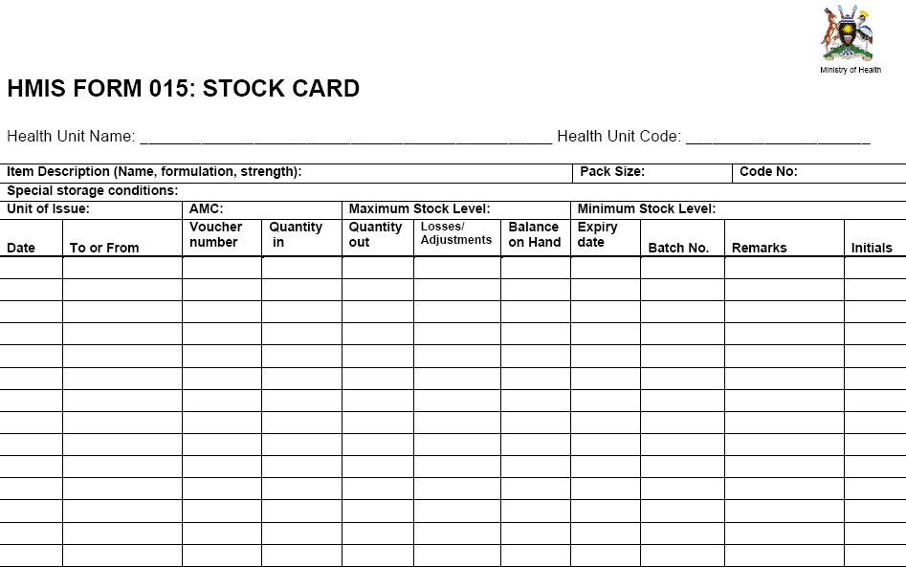

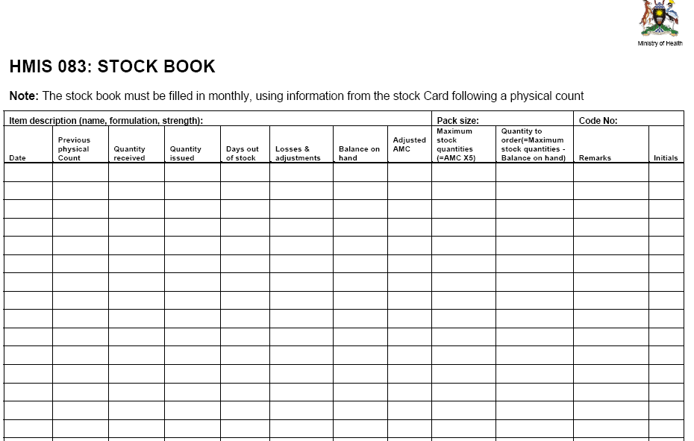

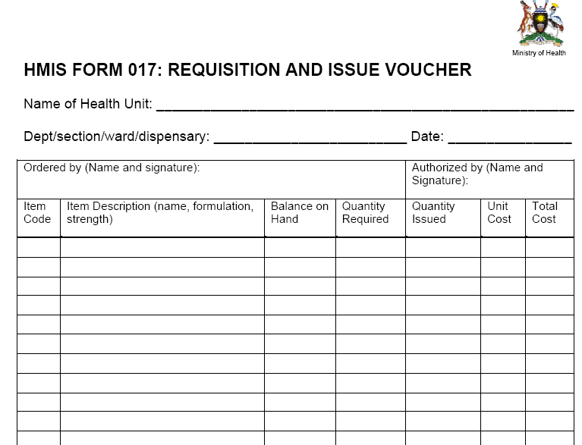

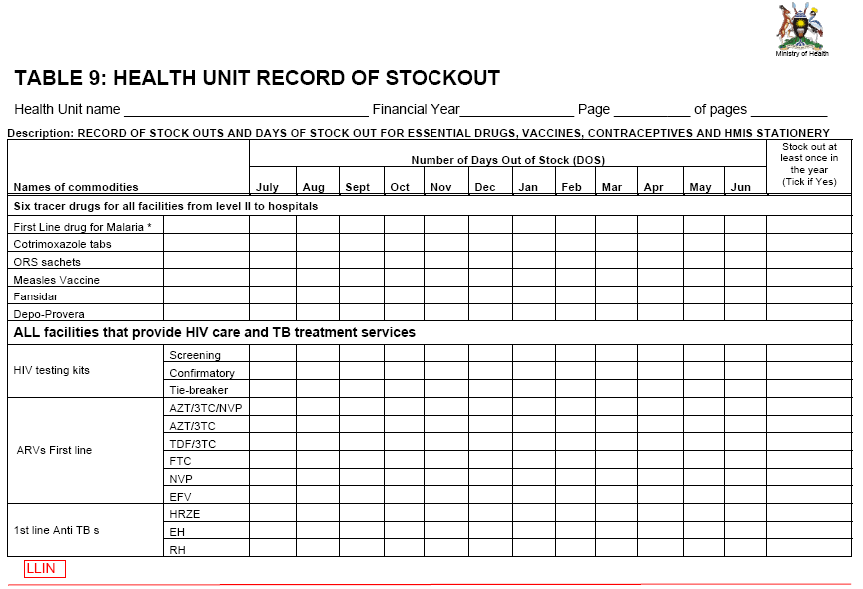

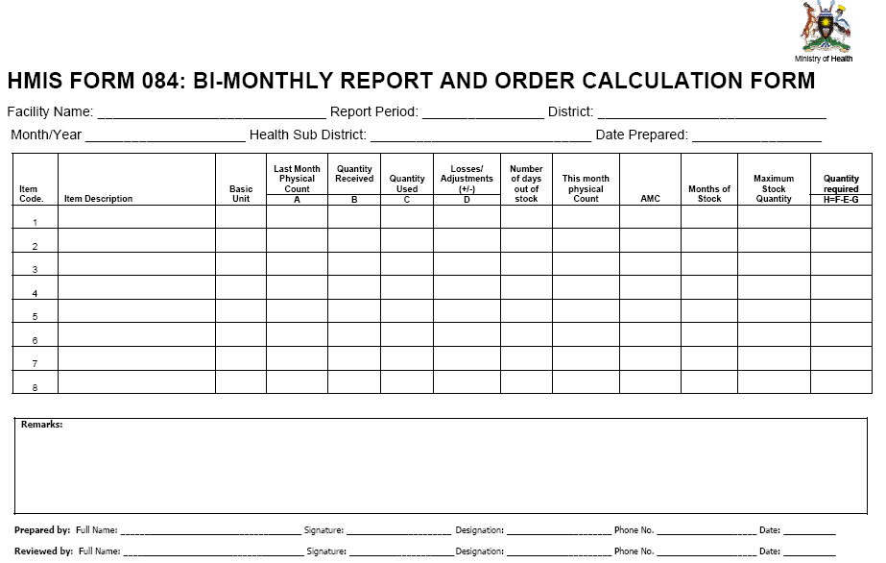

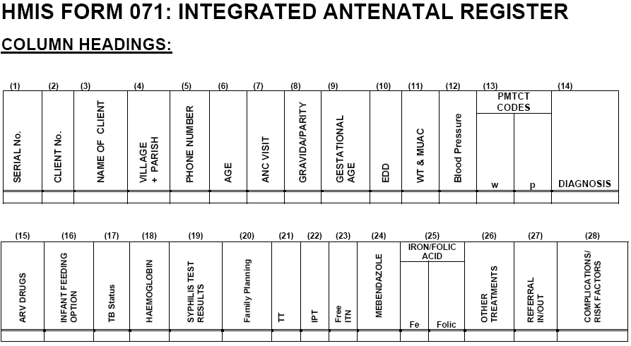

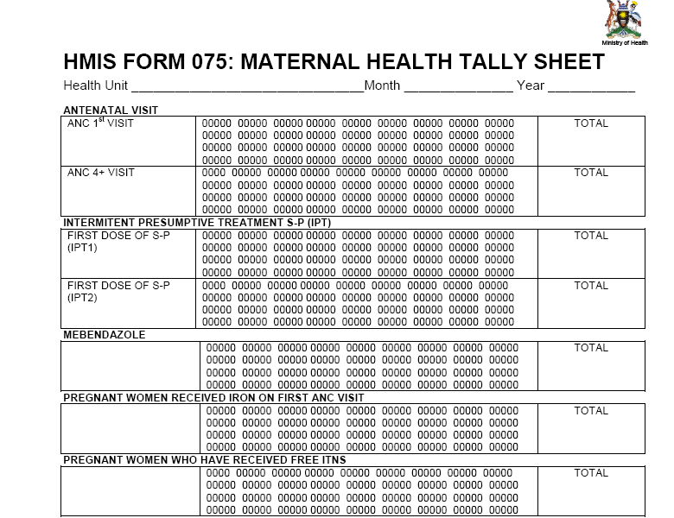

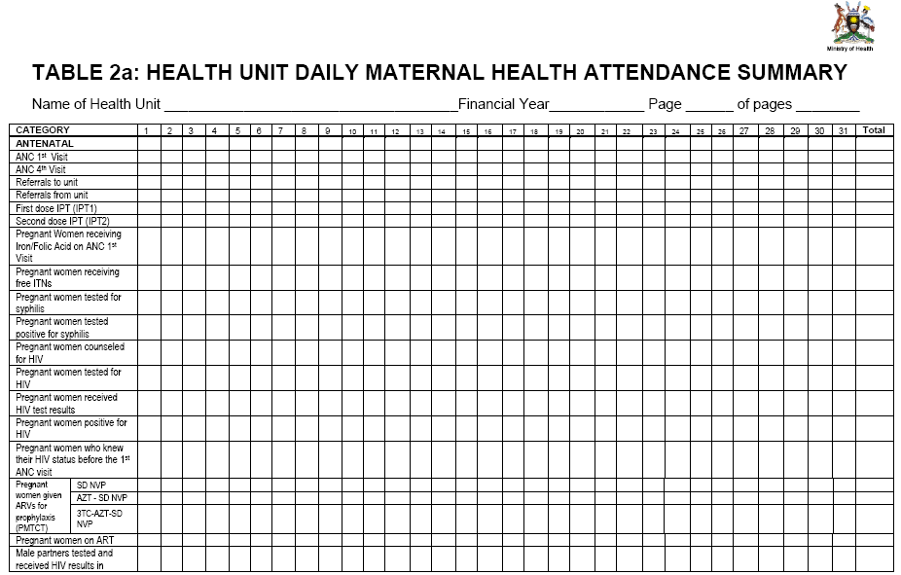

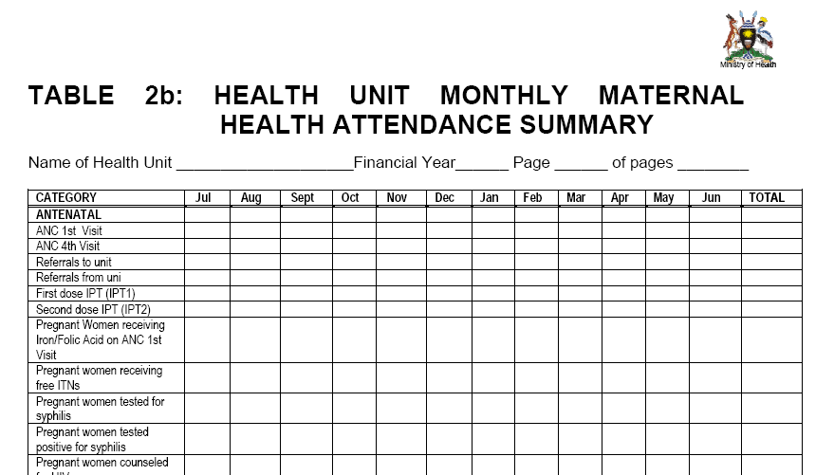

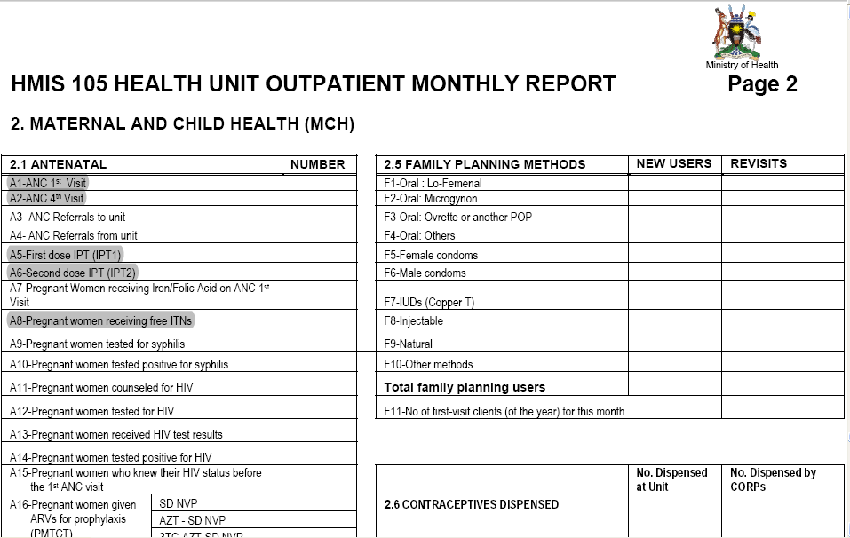
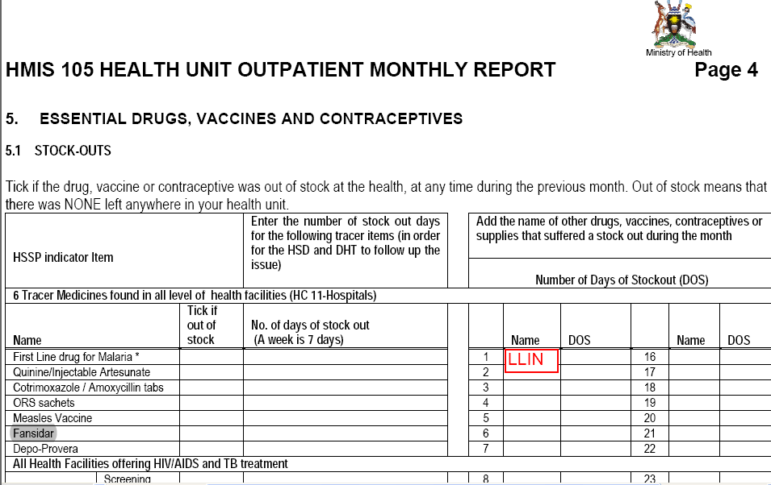

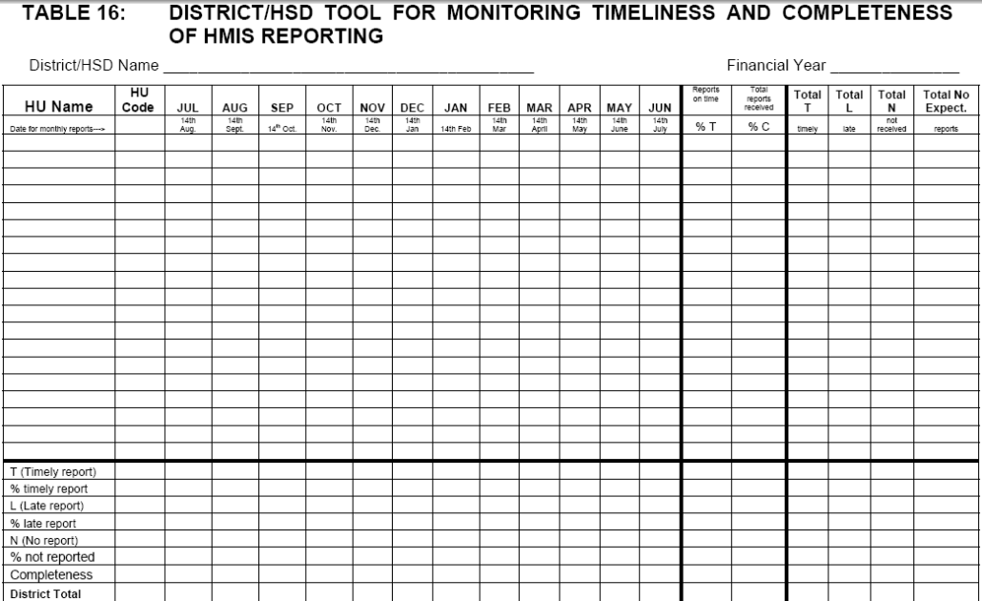

“Evaluation of the USAID/PMI funded AFFORD Project” Draft, 2010

